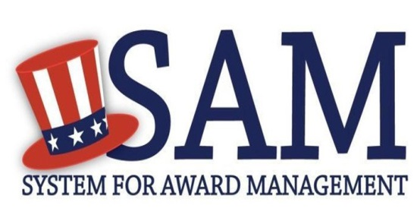
Quick Start Guide For New Grantee Registration

Helpful Information

What is an Entity?
In SAM, your company / business / organization is referred to as an “Entity.” You register your entity to do business with the U.S. Federal government by complet- ing the registration process in SAM.

SAM is the official free, government- operated website – there is NO charge to register or maintain your entity registration record in SAM.

What do I need to get started? DUNS Number
You need a Data Universal Numbering System (DUNS) number to register your entity in SAM. DUNS numbers are unique for each physical location you are regis- tering.

If you do not have one, you can request a DUNS number for free to do business with the U.S. Federal government by visit- ing Dun & Bradstreet (D&B) at http://fedgov.dnb.com/webform
It takes no more than 1-2 business days to obtain a DUNS number.

Taxpayer Identification Number
You need your entity’s Taxpayer ID Num- ber (TIN) and taxpayer name (as it ap- pears on your most recent tax return).
Foreign entities that do not pay employ- ees within the U.S. do not need to provide a TIN. Your TIN is usually your Employer Identification Number (EIN) assigned by the Internal Revenue Service (IRS).

Sole proprietors may use their Social Secu- rity Number (SSN) assigned by the Social Security Administration (SSA) as their TIN, but are strongly encouraged to obtain a free EIN from the IRS by visiting: http:// www.irs.gov/Businesses/Small-Businesses-&
-Self-Employed/How-to-Apply-for-an-EIN Allow approximately two weeks before your new EIN is ready for use when regis- tering in SAM.
Steps for Registering

Type www.sam.gov in your Internet browser address bar.
- Create a SAM Individual User Account (be sure to validate your e- mail address), then Login.
- Select “Register New Entity” under “Register/Update Entity” on your “My SAM” page.
- Select your type of Entity. Definitions are in the Glossary to the right.
- If you are registering in SAM.gov so you can apply for a Federal fi- nancial assistance opportunity on Grants.gov, and are not inter- ested in pursuing Federal contracts, you will have a much shorter registration path. To chose this “grants only” path:
  - Select “No” to “Do you wish to bid on contracts?”
  - Select “Yes” to “Do you want to be eligible for grants and other federal assistance?”

Complete the “Core Data” pages:
  - Validate your DUNS information.
  - Enter Business Information (TIN, etc.) This page is also where you cre- ate your Marketing Partner Identification Number (MPIN). Write the MPIN down as it will serve as a password for you in other govern- ment systems. You will need it for your Grants.gov registration.
  - Enter your CAGE code if you have one, but remember, CAGE
codes are tied to DUNS numbers and cannot be reused. Don’t worry if you don’t have a CAGE code for the DUNS number you are registering: one will be assigned to you after your registration is submitted. Foreign registrants must enter their NCAGE code before proceeding.
  - Enter General Information (business types, organization structure, etc.) about your entity.
  - Provide your entity’s Financial Information, i.e. U.S. bank Electronic
Funds Transfer (EFT) Information for Federal government payment purposes. Foreign entities do not need to provide EFT information.
  - Answer the Executive Compensation questions.
  - Answer the Proceedings Details questions.

Complete the “Points of Contact” pages:
  - Your Electronic Business POC is integral to your Grants.gov regis- tration and application process. Your Government POC will be used by other government systems, such as CAGE, when they contact you. List someone with direct knowledge of this registra- tion for both of those POCs.

Make sure to hit [Submit] after your final review. You will get a Con- gratulations message on the screen. If you do not see this message, you have not submitted your registration.
  - There are two external validation steps, one with the IRS and an- other with CAGE, after you submit. You will receive an email from SAM.gov when your registration is active.
Please give yourself plenty of time before your grant application submission deadline. Allow up to 7-10 business days after you submit before your registra- tion is active in SAM, then an additional 24 hours for Grants.gov to recognize your information.
For help registering in SAM, contact the supporting Federal Service Desk (FSD) at https://www.fsd.gov/

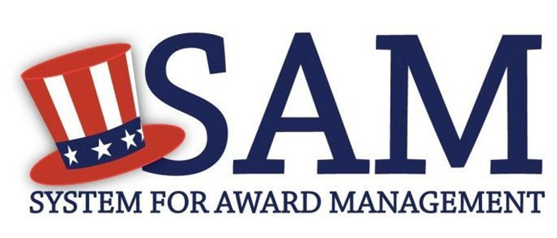

Helpful Information
Quick Start Guide for Updating/Renewing an Entity

What is an Entity

In SAM, your company/business/ organization is now referred to as an “Entity.”

Viewing Your Entity Record
How you view your entity record depends on several factors
- If you chose to make your record public, you can view your entity record by going to www.sam.gov and searching for your DUNS number or Entity Name
- If your record is available in the public search, but expired, you can view it by searching for your entity by DUNS number or Entity Name, clicking on the “Inactive” box, and clicking the “Apply Filters” button
- If you opted out of the public search, log into SAM, migrate your roles, and the click on “Register/Update Entity” and “Complete Registrations” to view your record

Requirements for Submitting Your Registration
- To submit your update, you must review the entire record in one sitting
- Review each page, validating the accuracy of the content
- If your registration requires Reps & Certs (formerly ORCA), make sure you select the box certifying to the accuracy of the data on the “Review Reps & Certs” page
Steps for Updating/Renewing an Entity

- Go to www.sam.gov and login with your SAM username and password
- Click “Register/Update Entity” and then “Complete Registrations” (if you started your update earlier, click on “Incomplete Registrations”)
- In the Entity List panel, click on the Entity you want to update/renew
- Click the Update Entity button in the “Registration Details” Panel
- Complete Purpose of Registration (You only have to do this once)
- Validate/Update “Core Data”
- Validate/Update “Assertions” (not required to be eligible for Grants only)
- Validate/Update “Representations and Certifications” (not required to be eligible for Grants only)
- Validate/Update “Points of Contact”, including optional POCs. If you no longer wish to have the optional POCs, please delete all data in these fields.
- If you qualify as a small business, validate/update your information in SBA’s Dynamic Small Business Search (DSBS) or apply for a small business certification on the “SBA Supplemental” page.
- Click Submit

Please note if your update/renewal requires IRS or CAGE revalidation, it will take 3-5 business days for it to become active and replace your previous registration.

System for Awards Management
www.sam.gov

Need Additional Help
www.fsd.gov toll free: 1.866.606.8220
international: 344.206.7828

