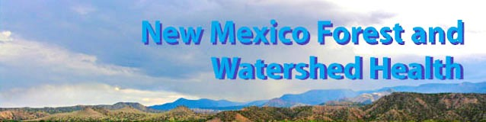

EMNRD Forestry Division
Forest and Watershed Health Office
FY2006-2007 Annual Report

The New Mexico Energy, Minerals and Natural Resources Department’s Forestry Division established its Forest and Watershed Health Office (FWHO) in July 2006 to facilitate implementation of the state Forest and Watershed Health Plan. The FWHO coordinates with other entities working toward a common goal of improved forest and watershed health, including enhanced wildlife habitat, reduced susceptibility to pathogens and wildfire, improved water quality and reduced wildfire risk to communities.
This first annual report describes the office’s accomplishments from its inception through June 2007.

Background
In March 2005, at a statewide gathering of watershed professionals, New Mexico Governor Bill Richardson signed the first comprehensive state Forest and Watershed Health Plan in the United States. The plan provides a framework for restoring the health of the state’s forests and watersheds through a collaborative, landscape-scale approach.
It recommends actions intended to transform the way ecological restoration is accomplished in New Mexico by strengthening on-the-ground efforts, eliminating unnecessary barriers to this work and, in the end, realizing much greater impact for the dollars invested.

The Forestry Division of the Energy, Minerals and Natural Resources Department, which stewarded the planning process, established the Forest and Watershed Health Office to facilitate and coordinate implementation of the twenty recommendations outlined in the Plan.

The Forest and Watershed Health Plan calls for three categories of action: (I) support for local on-the-ground efforts; (II) state-level strategic planning and coordination; and (III) state-level management and administration. Each of the twenty recommendations in the Plan identifies action items that fall under one of those categories. The FWHO undertakes action items which, combined with activities of Forestry’s state and district offices and the New Mexico Forest and Watershed Restoration Institute, result in progress in all three categories.

For FY2006-2007, the FWHO selected a set of actions based on priorities identified in an internal strategic planning session, conversations with people in the field, and input from an October workshop convened for that purpose. Although the office focused primarily on actions related to six of the Forest and Watershed Health Plan’s recommendations, it did not limit its work exclusively to them. As the plan’s authors pointed out, many of the recommended actions are interrelated and must therefore be undertaken simultaneously and iteratively. To maximize results, the FWHO chose to work on several activities that related to more than one recommendation.

Summary
In the first year FWHO concentrated on tasks that would jumpstart the Division’s forest and watershed health program. Items dealing with capacity building came first: situating and furnishing a physical office, establishing organizational setup, and staffing. Advertising our existence and purpose required networking within state government and strengthening or building relationships with other agencies, organizations and stakeholder groups. The 2006 Forest and Watershed Health Conference in Albuquerque initiated new connections and rebooted established ones. Many meetings, field visits, and informal conversations built on them over the course of the year.

Next came setting up mechanisms for regular communication on topics of common interest to those involved in ecological restoration. FWHO convened a Coordinating Group to facilitate open dialog between major agency and public sector representatives and provide input to staff. Together with two other departments it initiated an interagency planning committee to organize a 2008 statewide watershed forum for project managers, planners, and stakeholders. EMNRD and FWHO staff created the nmwatersheds.org website and continue to populate it with information that, in coordination with other linked websites, serves as a comprehensive clearinghouse of information on forest and watershed health in New Mexico.

In addition, the office provided technical assistance to agency personnel and to local collaborative groups working on forest and watershed projects. FWHO staff took over management of the Division’s Community Wildfire Protection Plan program and worked in tandem with the New Mexico Association of Counties and BLM on their parallel CWPP grant program. They also assisted NMSF District Offices with support in planning and overseeing on-the-ground efforts.

The following section describes these and other activities undertaken by the Forest and Watershed Health Office in its first year.

Accomplishments
The majority of action items undertaken in FY2006-2007 addressed the following six recommendations from the New Mexico Forest and Watershed Health Plan:
I.A - Support Local Collaborative Projects
I.E - Create Comprehensive Information Clearinghouse
II.A - Assess Statewide Ecological Condition
II.F - Mitigate Administrative Barriers
III.A - Establish State Leadership Authority
III.B - Establish Representative Advisory Group.

Some of the FWHO’s activities addressed more than one of the six prioritized recommendations. Some addressed other recommendations from the Plan as well. The accomplishments described below are listed under the most directly applicable recommendation.

Several long term initiatives begun in 2006 will continue to appear in future years’ work plans.

Establish State Leadership Authority
The authors of the Forest and Watershed Health Plan recognized the need for a state “leadership authority” with personnel devoted to the task of facilitating implementation of the Plan, but did not specify the form that authority would take. State Forestry, which had stewarded the Plan’s development, took on the responsibility for following through. The Division commenced the process by hiring staff to establish the Forest and Watershed Health Office and coordinate implementation of the Plan’s recommendations.

The FWHO is headed up by the Forest and Watershed Health Coordinator, Susan Rich, who joined the Division in July 2006. Jeremy Kruger began work in his position as Forest Health Specialist in October, and Terrell Treat as Wildland-Urban Interface Specialist in March 2007. The Watershed Health Specialist position was advertised in early summer with the new hire, Jessica Ouzts, scheduled to start after the beginning of the fiscal year.

The FWHO is housed in State Forestry’s Albuquerque office at 4001 Edith Boulevard NE. Staff, initially stationed at the Division’s Santa Fe office, moved into the building which they share with the Albuquerque Inmate Work Camp supervisor after IWC was relocated from Grants in Spring 2007.

Introduction of the FWHO to the community of natural resource professionals working in New Mexico began through networking with Forestry’s current partners and outreach to additional entities. Staff met with numerous state, federal, tribal and non-governmental partners in the field or at their offices. The FWHO made presentations or was represented at many interagency meetings.¹

FWHO staff served as members or officers on a number of collaborative teams and interagency committees. They participated as technical advisors in project planning, field assessments, proposal review and evaluation, and program design.

The FWHO keeps regular contact and coordinates many of its activities with the New Mexico Forest and Watershed Restoration Institute, one of three such institutes formed to ensure that the best available science is used to implement effective restoration-based forest treatments in the southwest.

Establish Representative Advisory Group
One of the first tasks undertaken by the FWHO was organizing and hosting the New Mexico Forest and Watershed Health Workshop in October 2006. Participants represented federal, state, local and tribal governments, private landowners, business, public interest groups and academia. Many were members of the original Planning and Executive Committees, but the list of attendees also included other forest and watershed health experts involved in current restoration efforts. Input gathered during the workshop helped formulate work strategies for the first year.

The workshop led to formation of a representative coordinating group established to help guide and facilitate implementation of the twenty action items in the Plan. Members decided to meet quarterly to find ways to address critical issues and collectively overcome impediments to getting more--and better--work done on the ground. The Coordinating Group agrees on a course of action, and identifies qualified personnel to form a Task Team to make it happen. The Coordinating Group held its first meeting April 17, with second meeting scheduled August 1, 2007.

The Coordinating Group assembled several Task Teams to tackle specific jobs. The GIS Task Team was charged with determining the feasibility of producing a database and map of forest and watershed projects planned, completed, or underway in New Mexico. At their June meeting, team members agreed on a short list of the types of information most useful to them and their constituents, and determined what data they could and could not provide. The project map will display point locations and metadata - project name, status, sponsor, type, components, latitude/longitude, acres, contacts, and weblink. The database is under construction and should be ready to populate by a pilot group of entities before the end of 2007.
The Public Outreach and Education Task Team and Strategic Planning Subcommittee were scheduled to meet in July, 2007.

Support Local Collaborative Projects
Participants in the October workshop overwhelmingly affirmed the Plan’s recommendation to continue, and expand, support for ongoing collaborative projects. FWHO staff began networking with staff and management in agencies, institutions and organizations even before the workshop.² They conducted field visits with stakeholders and managers at project sites across the state.³

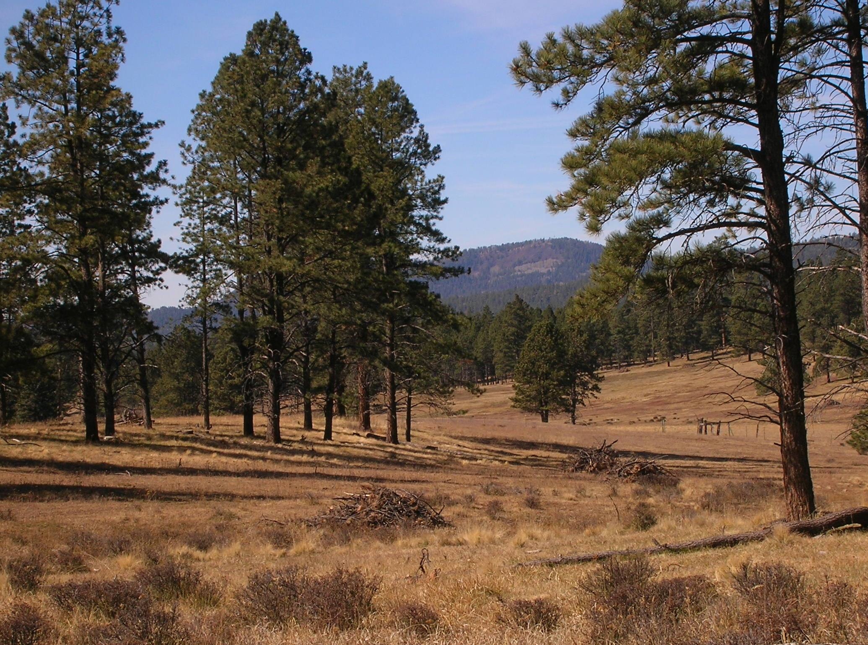
FWHO assumed responsibility for managing all Community Wildfire Protection Plan grants funded by State Forestry this year. A number of federal forestry grant programs will only accept proposals from communities that have a signed CWPP in place. The Wildland-Urban Interface Specialist worked with the District Fire Management Officers to help guide recipients through administrative processes, attend Core Team organizing meetings and assist CWPP project coordinators and technical contractors. FWHO also coordinated with BLM and the New Mexico Association of Counties on assistance to several counties they funded. In a growing number of communities, the collaboration required by the CWPP planning process has fostered coordinated projects on the ground.

The FWHO is a member of the assessment team evaluating the effectiveness of multi-agency projects in the greater Ruidoso area. This effort is being viewed as a model that can be emulated elsewhere in the state.

Staff participated in meetings or events of local collaborative groups and provided technical assistance for on-the-ground projects.⁴ Types of assistance included: guidance in developing RFPs, agreements, and reporting forms; maps, prescriptions, and work plans; transferring technology between parties working in the same watershed, developing similar tools, or addressing similar ecological problems in different locations; and participating in multi-entity planning, monitoring and implementation efforts.

Create Comprehensive Information Clearinghouse
FWHO and EMNRD staff designed and launched a website, nmwatersheds.org, containing information about the program and resources for users. Tools include a funding guide, calendar of relevant events and dates, and a virtual library of publications on forest and watershed health issues and links to partner websites. A task team is exploring the feasibility of developing a full-blown New Mexico watershed portal.
The FWHO, in consultation with GIS specialists from other agencies, began construction of a database of forestry and watershed projects across the state. The resulting map will depict project locations with pop-up windows describing status, type of project, contact information, and other metadata. Where available, weblinks will allow access to more details.

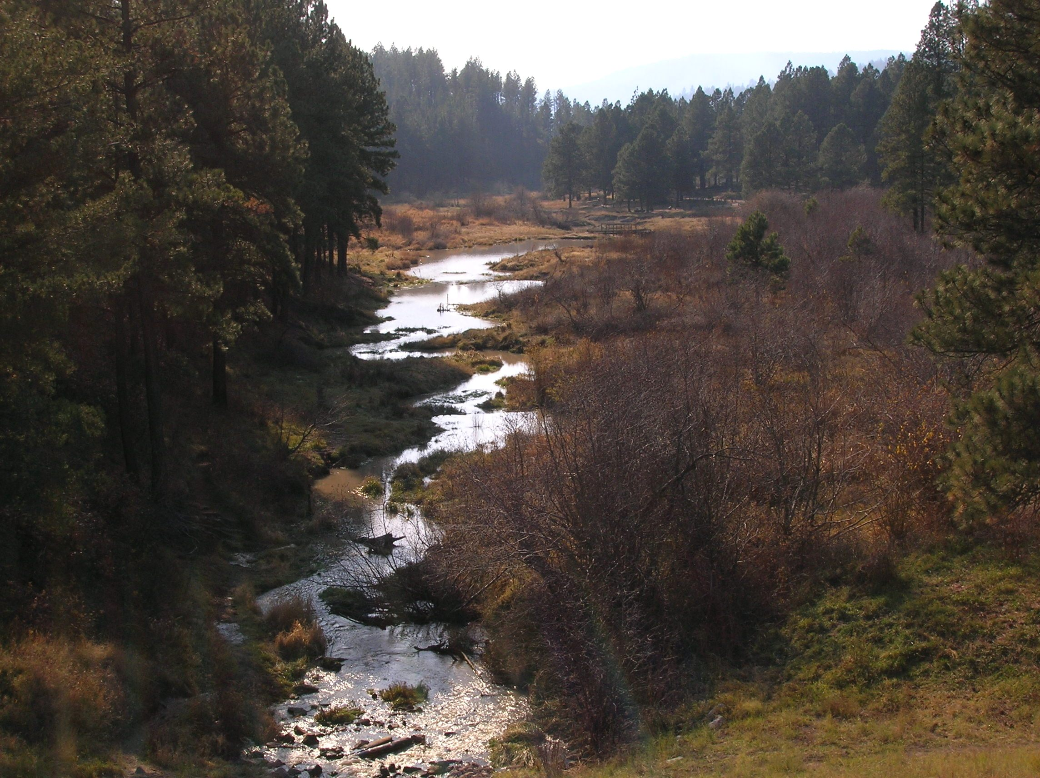
Assess Statewide Ecological Condition
The Forest and Watershed Health Plan calls for an assessment to provide baseline information about current ecological conditions to be used to measure success in restoration efforts. FWHO staff compiled a report on different assessment methods and their applications for the Coordinating Group, which formed an ad hoc committee to garner support needed to develop a web-based data atlas for that purpose.

Mitigate Administrative Barriers
Participants in the October workshop were polled to identify common barriers to getting work done on the ground. More recent results are expected from a survey of watershed groups designed by the National Park Service’s RTCA Program with input from the FWHO. The Coordinating Group formed a Task Team to explore options and develop tools for addressing some of those barriers. Workshops planned for the 2008 Watershed Forum will provide some of those tools and information to participants.

In conclusion
The plan of work for FY2007-08 builds upon the accomplishments of the past year and incorporates additional action items from the Forest and Watershed Health Plan. The work plan has been approved by the State Forester and the Coordinating Group.
Implementation of the Plan’s recommendations is a long-term commitment. The commitment of individuals to improving conditions of New Mexico’s ecosystems was evidenced even before the original planning committee was assembled. Success will require continued collaborative efforts between federal, state, local and tribal governments, private landowners, business, public interest groups and academia toward the ultimate goal of ecological restoration for the state’s forests and watersheds.

Coordinating Group Representation

Bureau of Indian Affairs
Bureau of Land Management
Energy, Minerals, and Natural Resources Department, Forestry Division
Natural Resources Conservation Service
New Mexico Association of Conservation Districts
New Mexico Department of Agriculture
New Mexico Department of Game and Fish
New Mexico Environment Department
New Mexico Forest and Watershed Restoration Institute
New Mexico State University
Public Sector
State Land Office
US Fish and Wildlife Service
US Forest Service

Notes

¹Adaptive Management Workshop I (Save Our Bosque Task Force)
Arizona ERI 2006 Annual Conference
Collaborative Forestry Restoration Program 2007 Annual Meeting
NM Association of Counties 2007 Annual Conference
NMAC/BLM Community Wildfire Protection Plan Committee
NM Association of Conservation Districts 2006 Annual Conference
NM Association of Conservation Districts 2007 Summer Meeting
NM Conservation District Employees Meeting
NM Interagency Weed Action Group
New Mexico Phreatophyte Management Conference
NRCS State Technical Committee
Society of American Foresters, NM Chapter
Soil and Water Conservation Society, NM Chapter
US Forest Service Workshop on Restoration of Fire Adapted Ecosystems

²Cimarron Watershed Association
The Nature Conservancy
River Source
Rio Grande Restoration
Forest Guild
Earth Works Institute
Santa Fe Watershed Association
NPS River, Trails, and Conservation Assistance Program

³Bosquecito and Socorro Save our Bosque Task Force projects
Burro Mountain WUI/319 projects and Mangas River revegetation
Carlsbad area federal EQIP rangeland and oil field restoration
Lower Pecos and Black River riparian area treatments
Fenton Lake and Sugarite State Park thinning projects
Jemez Wildland-Urban Interface projects
NM Department of Game and Fish potential project sites
Galisteo Watershed proposed riparian and wetland project sites
Gila National Forest thinning projects
Gila and San Francisco River restoration projects
Gila WoodNet, Reserve sawmill, Zuni Mountain facilities
Malpai Borderlands Group projects
Rio Puerco Initiative and other RPMC projects
Santo Domingo Pueblo upland restoration & phreatophyte control projects
San Francisco River Association greenhouse/seed production facilities
Taos Pines, Chama, Ruidoso, East Mountain area thinning projects

⁴Cuba Region Economic Development Organization
Estancia Basin Water Trust Board Steering Committee
Galisteo Watershed Partnership
Grants Wood Cluster meetings
Malpai Borderlands Group’s Ranching Today Workshop
Middle Rio Grande Bosque Restoration Quarterly Meetings
Quivira Coalition Annual Workshop
Rio Puerco River Cleanup Day
DeBaca, Bonita Lake, Cole Ranch and Candy Kitchen projects

