New Mexico State Forestry
Forest and Watershed Health Office

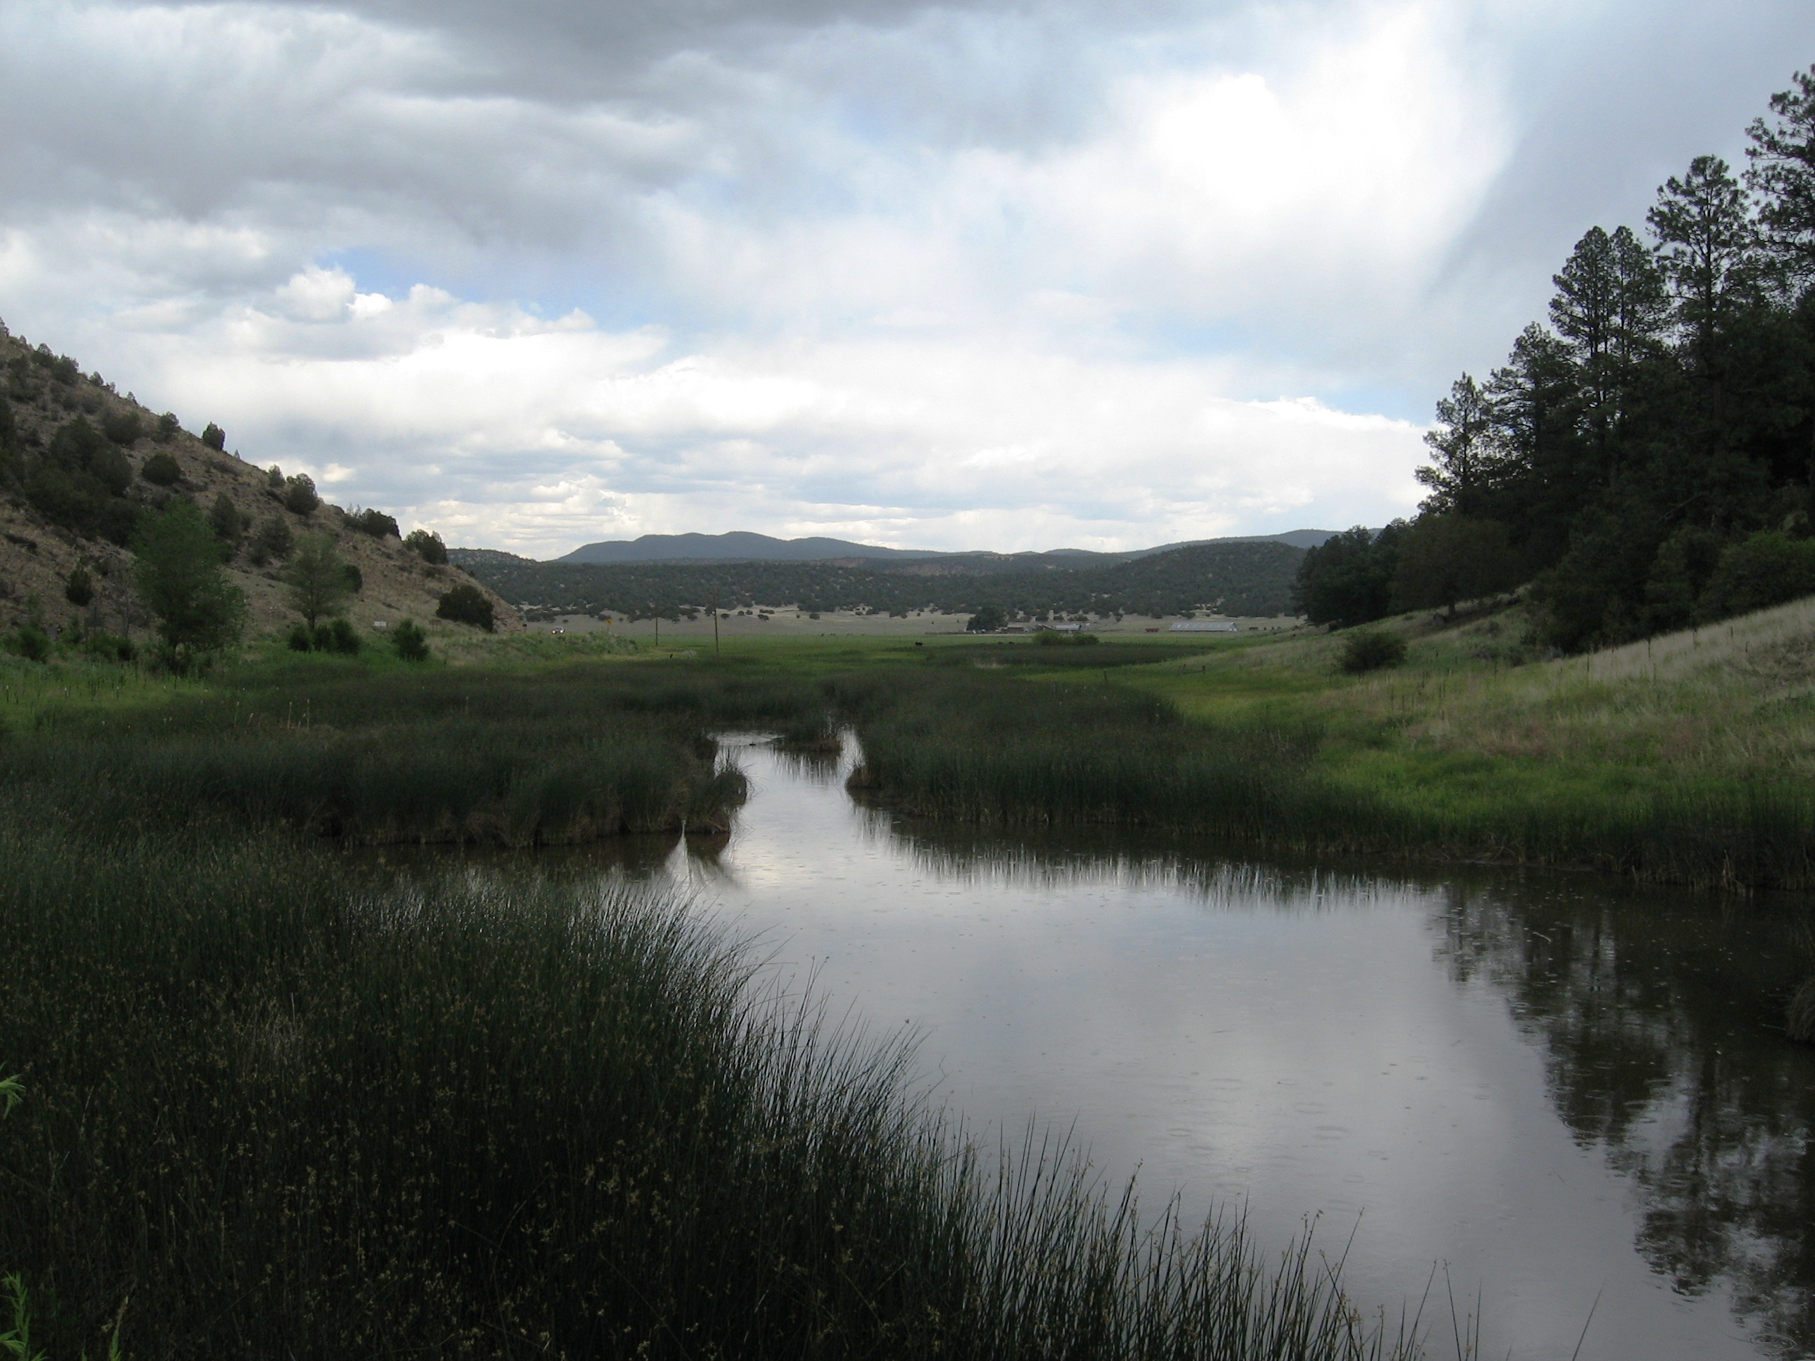

2007-2008 Annual Report

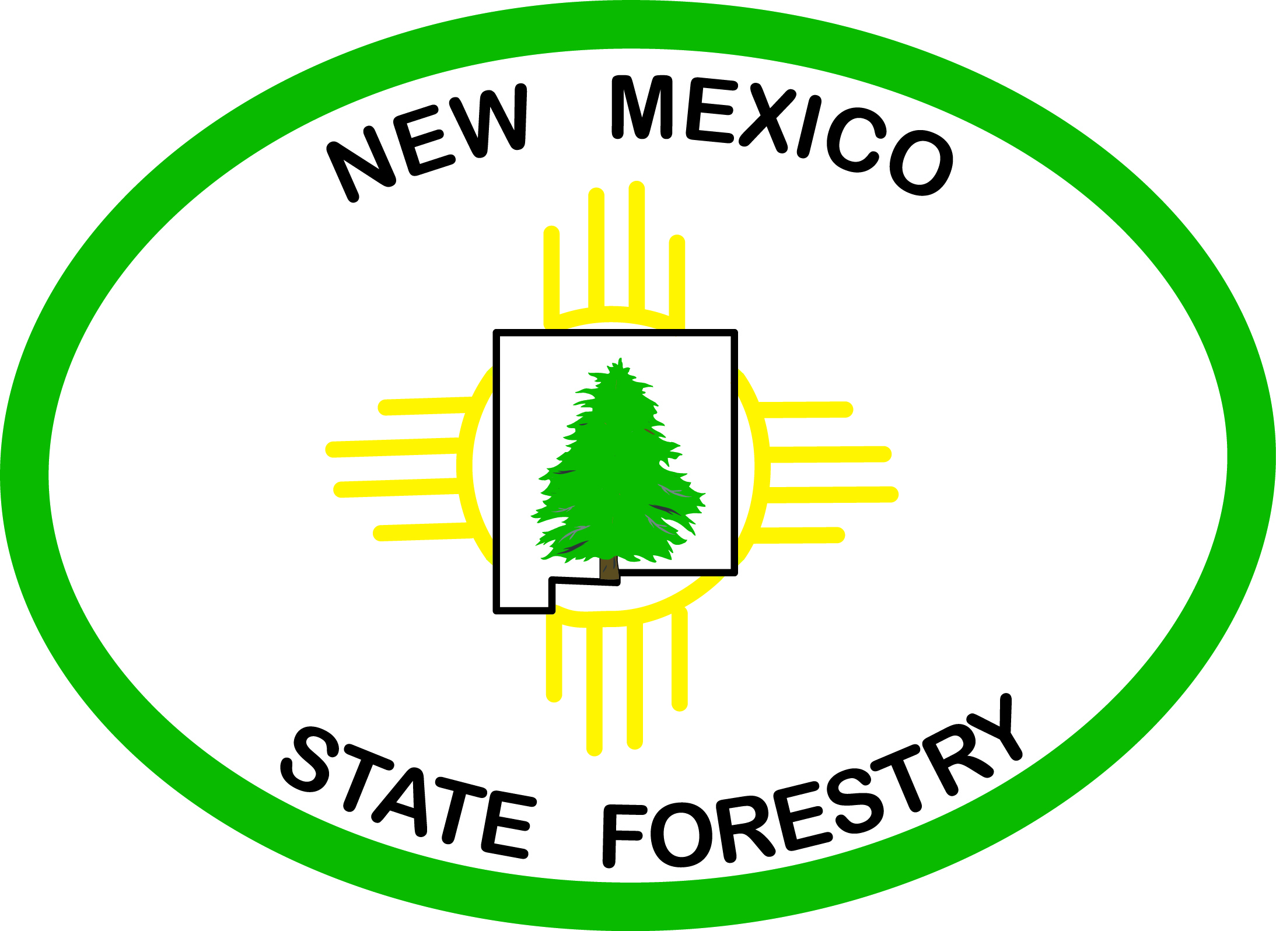
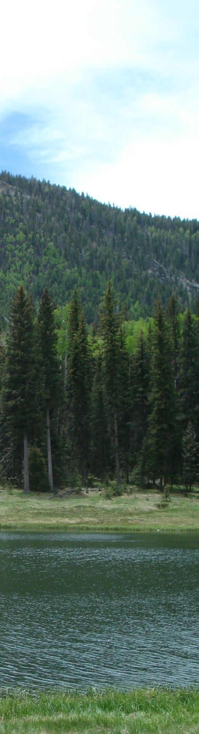

EMNRD Forestry Division
Forest and Watershed Health Office
FY2007-2008 Annual Report

The New Mexico Energy, Minerals and Natural Resources Department’s Forestry Division established its Forest and Watershed Health Office (FWHO) in July 2006 to facilitate implementation of the state Forest and Watershed Health Plan. The FWHO coordinates with other entities working toward a common goal of improved forest and watershed health, including enhanced wildlife habitat, reduced susceptibility to pathogens and wildfire, improved water quality and reduced wildfire risk to communities.

New Mexico’s Forest and Watershed Health Plan provides a framework for restoring the health of the state’s forests and watersheds through a collaborative, landscape-scale approach. It recommends actions intended to transform the way ecological restoration is accomplished in New Mexico by strengthening on-the-ground efforts, eliminating unnecessary barriers to this work and, in the end, realizing much greater impact for the dollars invested.

FWHO is charged with coordinating implementation of the twenty recommendations outlined in the Forest and Watershed Health Plan.

This report describes the office’s accomplishments during the 2007-2008 fiscal year.

Summary

The FWHO takes a multi-pronged approach to implementing the State Forest and Watershed Health Plan, which calls for three categories of action: (I) support for local on-the-ground efforts; (II) state-level strategic planning and coordination; and (III) state-level management and administration. Each of the twenty recommendations identifies action items that fall under one of those categories. The FWHO undertakes action items which, combined with activities of Forestry’s state and district offices and the New Mexico Forest and Watershed Restoration Institute, result in progress in all three categories.

I. Actions in support of local on-the-ground efforts - The FWHO conducts activities that directly support local collaborative restoration efforts.

- FWHO staff, working closely with our District Offices and other agencies’ field staff, provide technical assistance to community groups and non-governmental organizations. Assistance may take the form of helping them draft plans, design projects, or secure funding or other resources to implement, monitor, and evaluate on-the-ground projects and outreach/education activities. Capacity-building is integrated into these activities.

- In FY2008, FWHO’s WUI Specialist managed 19 State Forestry grants to produce county-wide Community Wildfire Protection Plans, and helped the New Mexico Association of Counties with proposal evaluation and project assistance on several more CWPPs.

- Staff participated either as members or technical advisors to regional and community groups involved in various stages of planning or carrying out forest and watershed restoration projects. They provided input and direct assistance during site visits to on-the-ground projects.

- The FWHO oversaw several state-funded forest and watershed health projects.

II. State-level strategic planning and coordination – The FWHO initiates and coordinates state-level actions that will result in changes that allow restoration work to be done more easily, more effectively, and more efficiently. Many of these actions are done through specialized task teams established by an interagency coordinating group.

- The Government Impediments Task Team is tackling two broad issues: First is resolving some of the institutional barriers leading to bottlenecks in cultural resource clearances for restoration projects. Second is providing clear, concise information about the NEPA process to restoration project partners in agencies, communities, and NGOs.

- The Public Outreach and Education Task Team supplied information sources and links for the nmwatersheds.org website’s virtual library, and ideas for a wide-ranging outreach and education program. In FY2009, the team will flesh out details of a Know Your Watershed Campaign that will promote better understanding of watershed health and support for conservation and restoration efforts.

- The GIS Task Team helped design a statewide project locator map and database, and is providing data to populate it.

- The Watershed Forum Planning Committee is well on its way to planning and organizing a statewide watershed forum co-hosted by five state agencies, funded in part by an EPA grant, and scheduled for 9/30-10/02/08.

- The Watershed Portal Task Team was formed to give input into the structure of the virtual part of a Comprehensive Information Clearinghouse on forest and watershed health topics.

- Most recently, the Coordinating Group approved formation of a Monitoring Task Force. It will be headed up by the New Mexico Forest and Water Restoration Institute.

- FWHO staff served on a number of interagency committees that deal with ecosystem restoration policy and special initiatives, develop grant programs, and review funding proposals.

- FWHO served as EMNRD forestry liaisons to commissions and other public bodies.

III. State-level management and administration - FWHO builds internal and external structures or mechanisms for supporting restoration work.

- The FWHO continued to build internal capacity within its own office, and through coordination with other Forestry units and the NM Forest and Watershed Restoration Institute.

- FWHO hosted 4 quarterly meetings of its multi-entity Coordinating Group that identifies issues in need of attention, proposes solutions, and establishes the task teams that tackle specific problems or produce desired products. A strategic planning subcommittee guides and reviews FWHO’s plan of work for the coming year.

FWHO Activities in FY2007-2008
This section of the Annual Report provides a detailed description of how the FWHO is implementing selected recommendations in the Forest and Watershed Health Plan.

Recommendation III.A - Establish State Leadership Authority
The framers of the New Mexico Forest and Watershed Health Plan envisioned a new office to provide organizational leadership to institutionalize implementation of the plan and to undertake coordination of the state’s ecological restoration activities. FWHO was established in July 2006 under the direction of Forest and Watershed Health Coordinator Susan Rich and was fully staffed by August 2007.

Jeremy Kruger is FWHO’s Forest Health Specialist. His combined experience in natural resource management and environmental law gives him solid background for coordinating project planning and oversight, while his wildfire training and experience furthers Forestry’s objectives of protection, prevention, and restoration of the state’s forests and watersheds.

Wildland-Urban Interface Specialist Terrell Treat puts his special talent for public outreach and communication to use by working closely with counties, communities, and other agencies to accomplish the Plan’s recommendations. His organizational skills, forestry degree, and extensive experience in fire issues contribute directly to his areas of concentration for the Division and the FWHO.

As FWHO’s Watershed Health Specialist, Jessi Ouzts provides technical assistance to landowners and other natural resource professionals. For much of the past year she has been concentrating on a special assignment assisting the USDA Natural Resources Conservation Service with updating and applying forestry practices through an interagency cooperative agreement.

Internal capacity-building was accomplished in a several ways. The office took advantage of staff development opportunities such as specialized trainings, hands-on fieldwork, and temporary assignments; obtained needed office and field equipment; and developed several successful funding requests and proposals for special projects.

One of FWHO’s leadership objectives is to help build strong partnerships. Staff served as members or officers on a number of collaborative teams and interagency committees. They participated as technical advisors in project planning, field assessments, proposal review and evaluation, and program design.

The FWHO keeps regular contact and coordinates many of its activities with the New Mexico Forest and Watershed Restoration Institute, one of three such institutes formed to ensure that the best available science is used in carrying out effective restoration-based forest treatments in the Southwest.

Recommendation III.B - Establish Representative Advisory Group
The Plan’s authors called for formation of an advisory group to advise and provide direction on implementation of the Plan, ensure coordination and outreach, and revise and update the Plan as needed. The multi-entity Coordinating Group meets quarterly to identify and address critical issues and collectively overcome impediments to getting more – and better – work done on the ground. The Coordinating Group agrees on a course of action, then forms a Task Team of individuals with the qualifications required to accomplish the specific task at hand. These Task Teams may function as standing committees for ongoing efforts or may be ad-hoc working groups, existing only until a particular job is done.

The Coordinating Group’s membership was expanded to include representatives from fifteen agencies and organizations by the end of the year. Five task teams held work sessions throughout the year for the following purposes:
Strategic Planning Subcommittee – review and contribute to FWHO’s annual work plan
GIS (Geographic Information Systems) Task Team – assist with design of statewide database and map of restoration projects
Public Outreach and Education Task Team – identify watershed-related information needs and ways to meet those needs through public awareness, outreach, and education
Government Impediments Task Team (including two working groups and special ad hoc committee) – focus on specific institutional impediments to conducting restoration work and take steps to mitigate unnecessary barriers. The team also serves as a host for facilitating cross jurisdictional problem-solving.
Watershed Forum Planning Committee – organize the first-ever statewide forum on watershed restoration in New Mexico, a joint effort of five state agencies.

FWHO also coordinated with other agencies, tribes, and organizations on a one-to-one basis. It represented EMNRD on a number of interagency committees that develop grant programs or review funding proposals. Input is focused on increasing collaboration between funders and project partners, connecting existing and planned projects to achieve larger results across jurisdictions, and integrating socio-cultural and economic concerns with natural resource management to accomplish meaningful restoration.

Recommendation I.A: Support Local Collaborative Projects
Landscape-scale restoration requires local collaborative groups to consider where their project lies within its watershed and the needs of that larger landscape. More and more funders stipulate that project proposals demonstrate the stakeholders’ grasp on the big picture. The FWHO provides information and services to enhance the capacity of stakeholder groups engaged in restoration, and support for developing comprehensive plans for dealing with problems on an ecosystem or landscape scale.

Staff responded to requests for technical assistance with on-the-ground projects by providing guidance in developing RFPs, agreements, and reporting forms; producing maps, prescriptions, and work plans; and participating in multi-entity planning, monitoring and implementation efforts.

A statewide project GIS map and an even more comprehensive natural resource map under development by the Forestry Division are two tools that will make it easier to put individual projects into perspective and to join forces to conduct landscape scale projects across jurisdictional boundaries. FWHO’s project map depicts forest and watershed projects that are planned, completed, or underway in New Mexico. It displays point locations and pop-up windows describing project name, status, sponsor, type of project, contact information, and other metadata. Where available, weblinks allow access to more details. The database was tested using State Forestry’s own project data. The GIS Task Team is providing additional datasets from state and federal agencies.

FWHO managed 19 grants to counties and communities developing Community Wildfire Protection Plans (CWPPs). In coordination with State Forestry’s District Offices, our WUI Specialist guided recipients through the plan writing process, attending Core Team and public meetings and assisting project coordinators and contractors. FWHO also worked with the New Mexico Association of Counties on a workshop for project coordinators and on development of four additional CWPPs funded through the Bureau of Land Management. In a growing number of communities, the collaboration required by the CWPP planning process has fostered coordinated projects on the ground.

Recommendation I.E: Create Comprehensive Information Clearinghouse
The FWHO responded to this recommendation by simultaneously taking on three tasks. First was creating its nmwatersheds.org website with its virtual library, funding guide, calendar of events, links to other forest and watershed health websites. Second was seeking input from many sources on what a truly comprehensive information clearinghouse should look like. Third was obtaining the funding it would take to make those ideas come to fruition.

At the close of the fiscal year, FWHO had signed an agreement with the FWRI to jointly produce the clearinghouse, had a team to design the web portal, and had obtained sufficient funding to get started.

Recommendation II.F: Mitigate Administrative Barriers
The Government Impediments Task Team was formed to critically evaluate and mitigate institutional impediments to getting work done on the ground in a way that restores watershed health while protecting all natural and cultural resources. Small working groups tackle very specific problems brought before the Coordinating Group. The Task Team took on two broad issues this year: resolving some of the institutional barriers leading to bottlenecks in cultural resource clearances for restoration projects; and providing clear, concise information about the NEPA process to restoration project partners in agencies, communities, and NGOs. Special subcommittees continue to work on both issues.

Recommendation I.H: Develop Public Outreach
Recommendation II.I: Educate Current and Future Generations
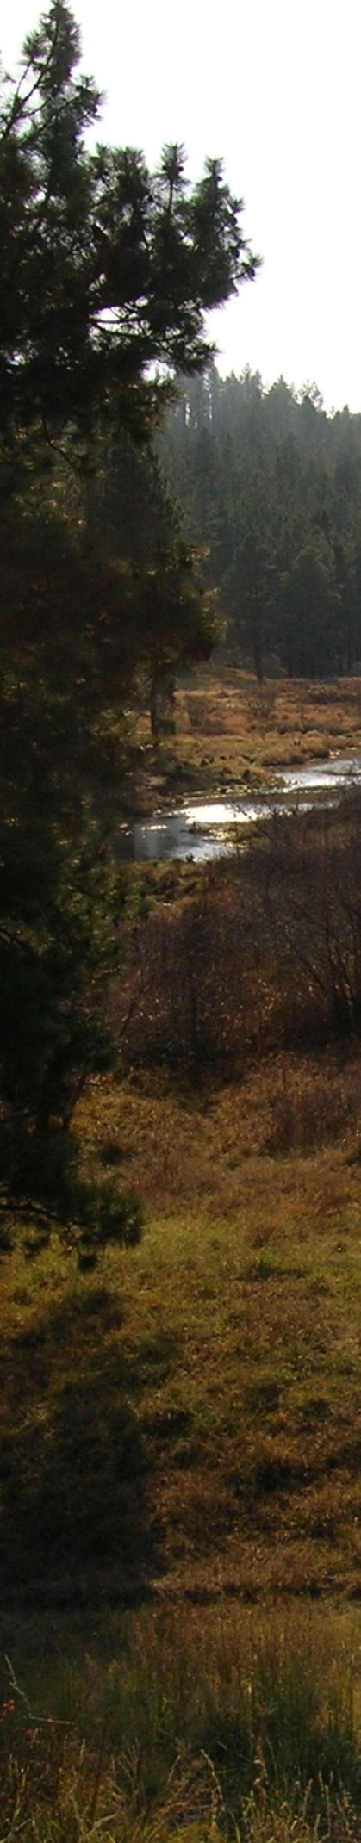
The Public Outreach and Education Task Team focused on three action items: expanding the nmwatersheds.org website’s reference library; finding funding to design and launch a public awareness campaign; and initiating production of a truly comprehensive information clearinghouse for forest and watershed health topics in New Mexico and the Southwest. The first item was accomplished in large part by Fall 2007. The website continues to be updated on a regular basis. FWHO secured a grant for the Know Your Watershed Campaign and agency funding for both the virtual and tangible components of the information clearinghouse. Members of the Task Team were poised to start these major projects at year’s end.

The Watershed Forum Planning Committee began as a joint effort of FWHO and the New Mexico Environment Department, and quickly grew to include the Forest and Watershed Restoration Institute and the state Departments of Agriculture and Game and Fish. The Committee is organizing a statewide forum for community groups, project managers, and agency staff engaged in improving watershed and forest health. The three-day event will feature plenary sessions and workshops designed to provide practical tools and information for participants, and a full day field trip to view restoration projects.

Recommendation I.F: Develop Ecological Restoration Practices
Recommendation I.G: Develop Ecological Monitoring Practices
FWHO joined forces with the Forest and Watershed Restoration Institute to promote ecological improvement and restoration based on the best available science. These action items were primary components of the Institute’s work plan. FWHO played a supporting role in initiating a joint watershed restoration seminar series, which entailed a 2-day statewide monitoring meeting and a daylong seminar on restoration in mixed conifer forests.

FWHO staff promotes incorporation of assessment, monitoring and adaptive management into project plans, and assists with training and conducting those activities. They coordinate with, and distribute information developed by the Southwest Ecological Restoration Institutes and others active in researching and developing science-based ecological restoration and monitoring practices.

