National Fish Passage Program
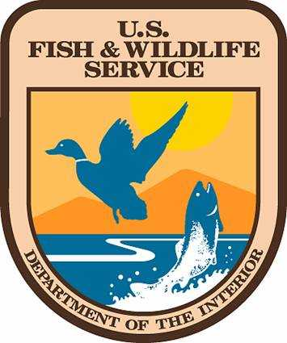
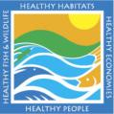

Request for Proposals
FY 2011

By
New Mexico Fish and Wildlife Conservation Office (NMFWCO)
U.S. Fish and Wildlife Service
Albuquerque, New Mexico

National Fish Passage Program
Through its National Fish Passage Program the U.S. Fish and Wildlife Service uses a voluntary, non-regulatory approach to remove and bypass barriers. The Program addresses the problem of fish barriers on a national level, working with local communities and partner agencies to restore natural flows and fish migration. The Program is administered by National and Regional Coordinators, and delivered by Fish and Wildlife Management Assistance Offices, with their 300 biologists located across the Nation. Appropriations for the Program support the Coordinators, in-the-water fish passage projects, and the Fish Passage Decision Support System. The program provides technical assistance and funding to assist others in restoring fish passage.

Program Goal
The goal is to restore native fish and other aquatic species to self-sustaining levels by reconnecting habitat that has been fragmented by barriers, where such re-connection would not result in a net negative ecological effect such as providing increased habitat to exotic species. Information on the National Fish Passage Program is available on the U.S. Fish and Wildlife Service website: http://www.fws.gov/fisheries/fwma/fishpassage.

Limitations
Proposals for funding should keep in mind the program goal of reconnecting habitat that has been fragmented by barriers. Renovation of culverts, dam removal, fishway designs, fish screens/ladders, repairing low flow road crossings, barrier inventories/assessments and restructuring water control structures have all been funded in the past. All projects must be located in New Mexico

Proposals are encouraged from: all federal, state, county, tribal and private organizations that wish to restore fish passage in New Mexico. Proposals will be evaluated for satisfaction of priority needs and be submitted into an internal database by NMFRO. Projects that receive the highest consideration will be those that show the greatest ecological benefits; exhibit permanence of fish passage benefits; make use of the most current scientific knowledge and proven technology; evidence the greatest public support; and generate the maximum in matching contributions.

Administration: Funding is administered through the Fish and Wildlife Service and direct coordination is provided by New Mexico Fish and Wildlife Conservation Office.

Partners, Cooperators and Matching funds: Preferred. The Program has flexibility from project to project but strives to achieve a 50% match, including in-kind contributions.

Deadline for Proposal Submission:10 January 2011

Proposals should be no more than three pages and should consist of:

Project Title
Project description
Total amount of funding requested and project duration
List of Partners/ Cooperators
Project Location/include UTM coordinates if possible
Applicant Organization
Project Officer and contact information

Submit an electronic copy to: Stephen_Davenport@fws.gov and Jim_Brooks@fws.gov or two hard copies to:

Stephen R. Davenport
U.S. Fish and Wildlife Service
New Mexico Fish and Wildlife Conservation Office
3800 Commons NE
Albuquerque NM, 87109
(505)342-9900 x 105

Please contact either Stephen Davenport or Jim Brooks for additional information/questions.

