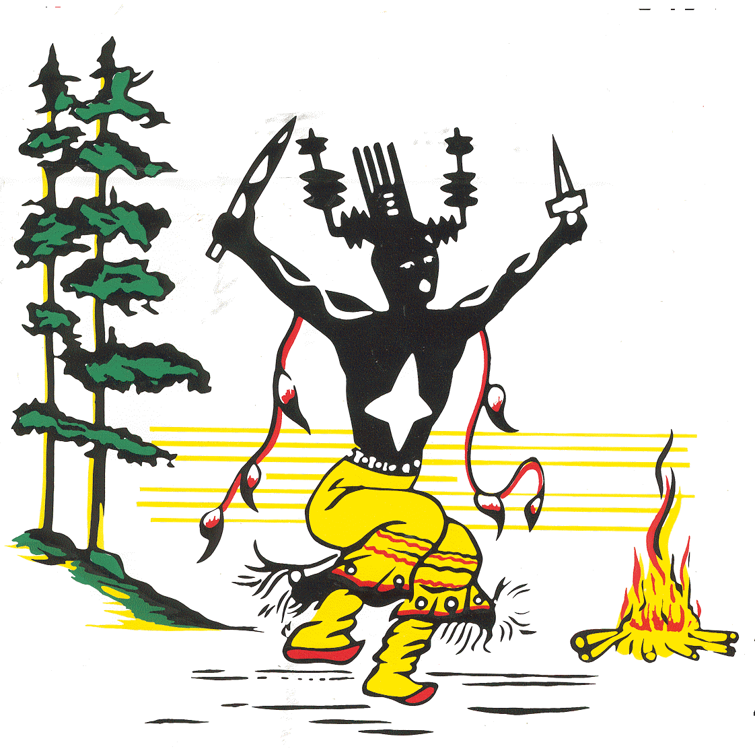

MESCALERO Apache TRIBE

Division of Resource Management & Protection

EMPLOYMENT ANNOUNCEMENT

POSITION: Water Quality Specialist – 1 position
Water Resource Management Section
PAYRATE: $19.00-$24.10/hour (dependent upon experience & qualifications)
LOCATION: Division of Resource Management and Protection, Mescalero, NM
CLOSING DATE: June 27, 2012 START DATE: July 9, 2012

Introduction
This position is located within the Water Resources Management Section of the Division of Resource Management and Protection (DRMP), and is under the direct supervision of the Water Resources Specialist. This position will involve approximately 50% time in the field and 50% time in the office.

Major Duties and Requirements
- Supervise data collection and monitoring of water quality on surface waters of the Mescalero Apache Reservation, and evaluate data to determine integrity of water bodies and need/extent for future watershed restoration projects to improve water quality. Data collection methods may include sampling physical and chemical parameters of waters, benthic macroinvertebrate sampling, physical/geomorphologic measurements of streams and/or delineations of wetlands, as determined by project objectives and funding sources.
- Promote community/departmental awareness and implementation of the Tribal Source Water and Wellhead Protection Plan and Tribal Water Quality Standards, as well as best management practices outlined in the Tribal Nonpoint Source Pollution Management Plan. As needed, develop additional best management practices for incorporation into Nonpoint Source Pollution Management Plan.
- Provide professional oversight to full-time technical staff and student
interns/volunteers that may assist with field data collection and project implementation.
- Update the department’s Quality Assurance Project Plan for data collection, as required by funding sources.
- Incumbent will be required to prepare and submit quarterly, annual, and final reports to funding agencies in order to meet funding requirements. Copies of all reports and deliverables will be provided to the Water Resources Specialist and DRMP Program Manager.
- In coordination with the Water Resources Specialist, develop a comprehensive watershed assessment for maintaining, improving and/or developing the water resources of the Mescalero

Apache Tribe. Collaborate with other disciplines, both DRMP staff and other land management entities, to further develop and implement water resource projects. Potential projects may include restore spring and surface water yield and quality, increase water available to wildlife and livestock through development of wells powered by renewable energy sources, and develop water resource projects in conjunction with recreational uses.
- Research funding opportunities and develop project funding proposals to address water resource needs on the Mescalero Apache Reservation.
- Collaborate with local watershed coalitions and schools to develop and implement watershed restoration projects and provide hands-on field learning experiences for staff and students.

Minimum Qualifications
- Bachelor of Science degree in hydrology or related natural resources field is required. Must demonstrate specific knowledge and skills in water quality, water resources and/or watershed management. Please provide copies of college transcripts with your resumé.
- Must possess good writing and communication skills.
- Must be proficient with computer, including daily use of Microsoft Word and Excel, and some use of PowerPoint.
- Must be proficient in reading/using topographic maps and/or have experience mapping with Global Positioning Satellites (GPS)
- Must be able to work well in an interdisciplinary team environment. A positive attitude and outgoing personality is essential.
- Previous experience working in mountainous terrains is preferred.
- Must possess valid state driver’s license and meet Tribal insurance standards.
- Selection will comply with “Tribal Preference Hiring” Ordinance 06-02.

Submit resumé to:

Dan Abercrombie, Water Resources Specialist
Division of Resource Management & Protection
Mescalero Apache Tribe
P.O. Box 250
Mescalero, New Mexico 88340
dan@mescalerodrmp.net

DRMP office is located across from the Mescalero Greenhouse Facility at 268 Pine Street.

