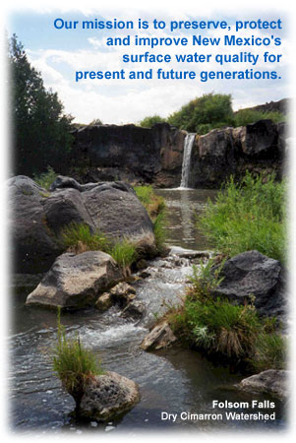


Surface Water Quality Bureau

New Mexico Environment Department

Table of Contents

Figure 1. Map of 319 Project History 1991-2005 1
Background Information 2
Endpoint Identification 2
Target Loading Capacity 2
Figure 1. Black Canyon Creek Land Use/Cover Map 3

Figure 2. Black Canyon Creek Ownership Map 4

Waste Load & Load Allocation 5
Waste Loads Allocation (WLA) 5
Load Allocation (LA) 5
Determining the Local Solar Radiation (SSSOLAR) 5
Figure 3. Model Components 6
Determining Solar Shading (SSSHADE) 7
Determining Resulting Stream Temperatures (SSTEMP) 9

Figure 1.
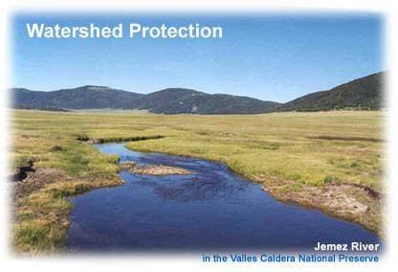
The Watershed Protection Section (WPS) coordinates watershed projects and implements best management practices (BMPs) for the prevention of nonpoint source (NPS) pollution largely caused by various land uses. The Section coordinates with other municipal, county and federal agencies to control this major type of pollution. WPS staff are responsible for associated data management and reporting activities concerning publicly-funded watershed projects statewide, as well. The program helps educate communities on proven water conservation efforts and low-cost pollution prevention methods. WPS provides bureau-wide support in developing and managing projects that protect state water quality standards and are required by the State's Water Quality Management Plan.
Watershed Protection Section staff and management are located in Santa Fe, Silver City, Las Cruces and Las Vegas. Staff in these offices are assigned to nearby portions of the state.
The WPS consists of three separate teams of specialized scientists, site supervisors and grant administrators that form a comprehensive nonpoint source pollution program for surface water quality restoration and remediation throughout New Mexico.
The WPS provides a major component of the protection of surface water resources in the state, and includes a combination of regulatory and voluntary programs to reduce nonpoint source pollution. Staff members within the section cooperatively work to educate others and implement best management practices to reduce nonpoint source pollutants from entering the surface and ground water resources of New Mexico. Projects developed and funded under Section (§) 319(h) of the Clean Water Act include a variety of efforts, including watershed association development, riparian area restoration, forest and rangeland restoration, urban storm water management, recreation management, public outreach, an others. The WPS also handles water quality certification of CWA § 404 permits and enforces portions of the New Mexico Mining Act pertaining to water quality.
Funding Source:

a. Type of Fund: Federal

b. Current (FY07) Request:

c. Fund Purposes (uses and restriction):

d. Funding issues (continuous, uneven, cyclical, competitively awarded, one time award, etc.). If federal, identify term of current grant:

e. If federal, match considerations (% of match required, type of match whether in-kind or direct, how match is obtained:

f. Future funding prospects and predictions (through FY08). Identify problems if funds will be running low or deficit:
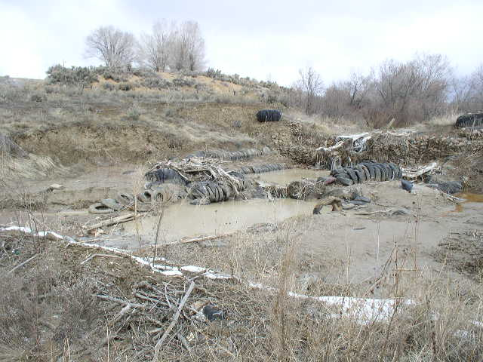
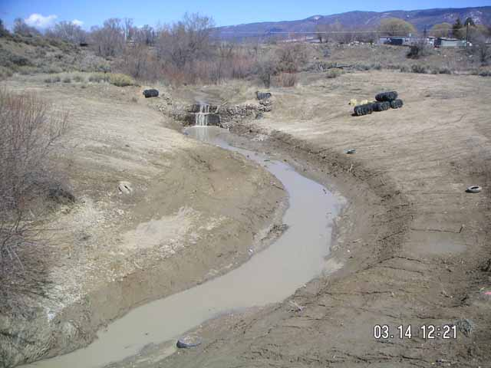
Rio Puerco in the Village of Cuba. The site was infilled with discarded tires and urban debris prior to project implementation.
Rio Puerco at Cuba following the removal of over 1,100 tires and the re-establishment of a meandering channel and new banks.

Project Map and Description:

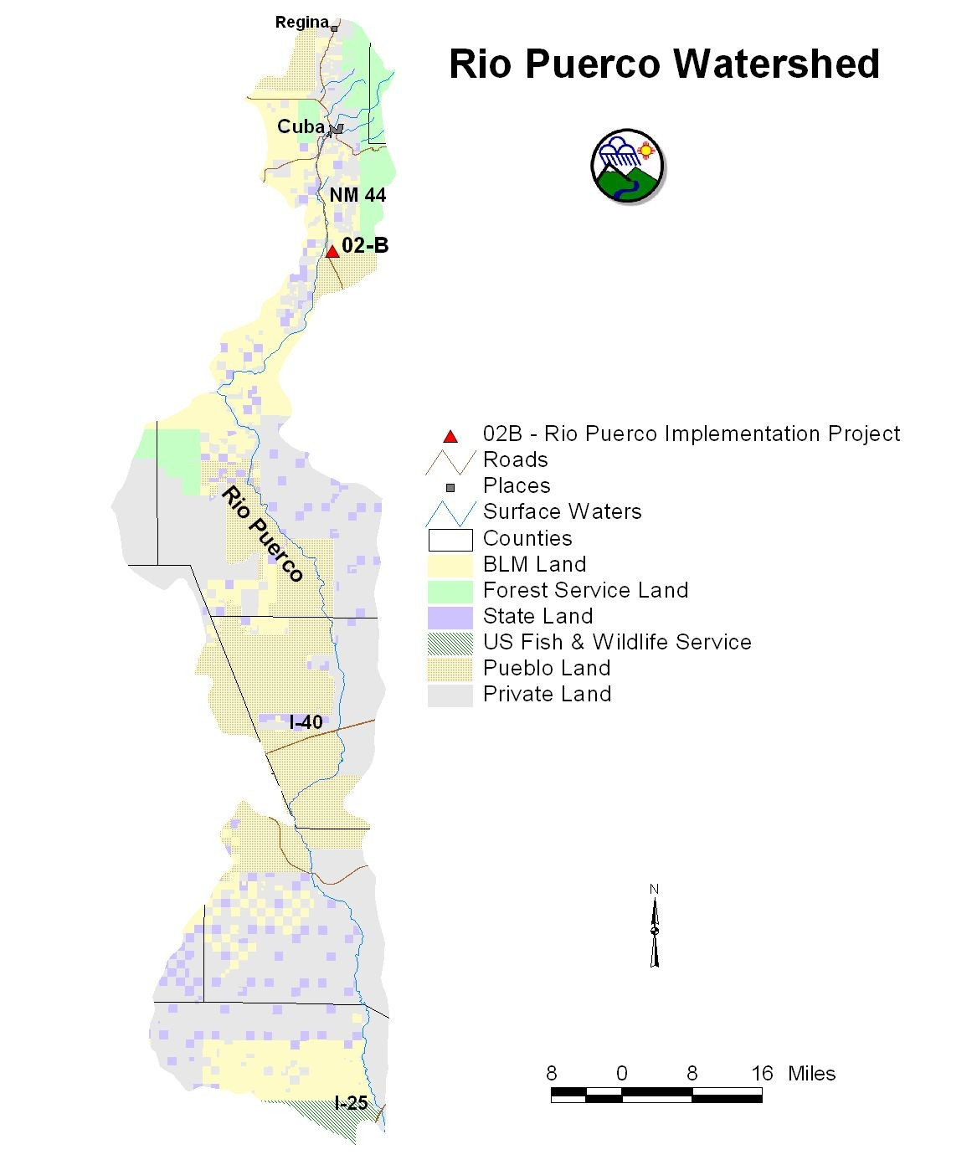

Rio Puerco Implementation Project (2002 $500,000 federal grant, $333,333.33 match, $833,333.33 total)

- 2000 the NMSH&TD is completed the final phases of a large State and Federal Highway 550 widening project between Bernalillo and Bloomfield.

- dominant objective of this FY 02-B project is to proceed with the on-the-ground implementation of construction designs and specifications, employing proper stream morphology, engineering and construction principals.

- activating a contract firm or a technical arm of the BLM, Bureau of Reclamation (BOR), or other agency to move berms, plug off and armor the current entrance into the river’s channelized segment, and complete other restoration elements identified by the BOR’s engineering design effort.

- project will close the channelized reach of the river, turn water back into the historic meandering channel, and construct local in-channel revetments to stabilize flows and prevent a reactivation of bank erosion in the once-again flowing channel segment.

- project’s planning, construction, and implementation elements, and the reintroduction of flow to the historic channel are anticipated to take up to two years to complete.

- “grand re-opening of the new river channel” is projected to be a major public outreach event, targeted for late 2004 - early 2005, once channel flows have resumed.

Project History:

Past Successes:

Current Challenges:

Future Plans:

Project Photos:

Before:
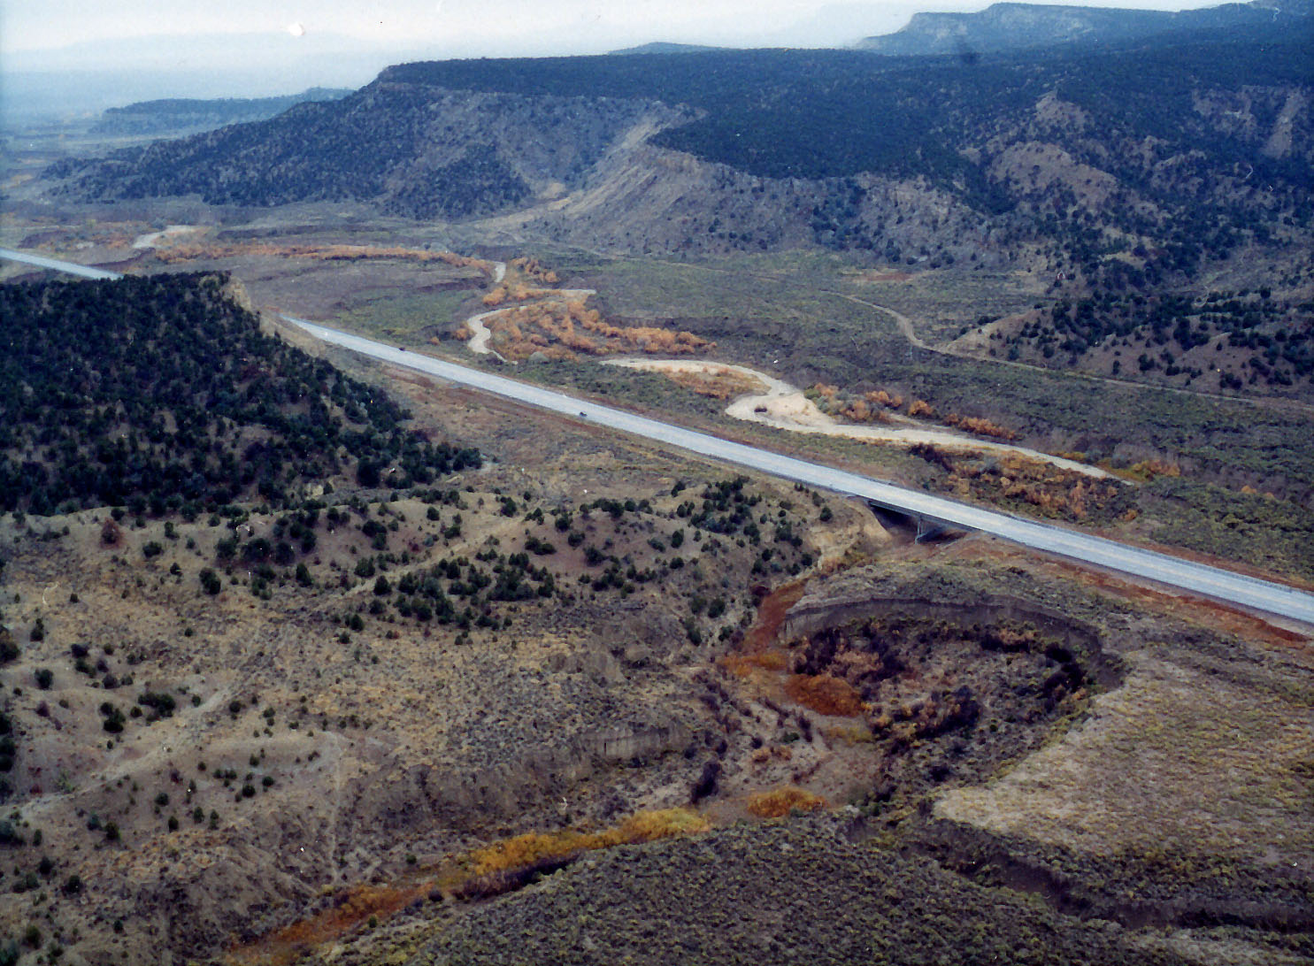

After:

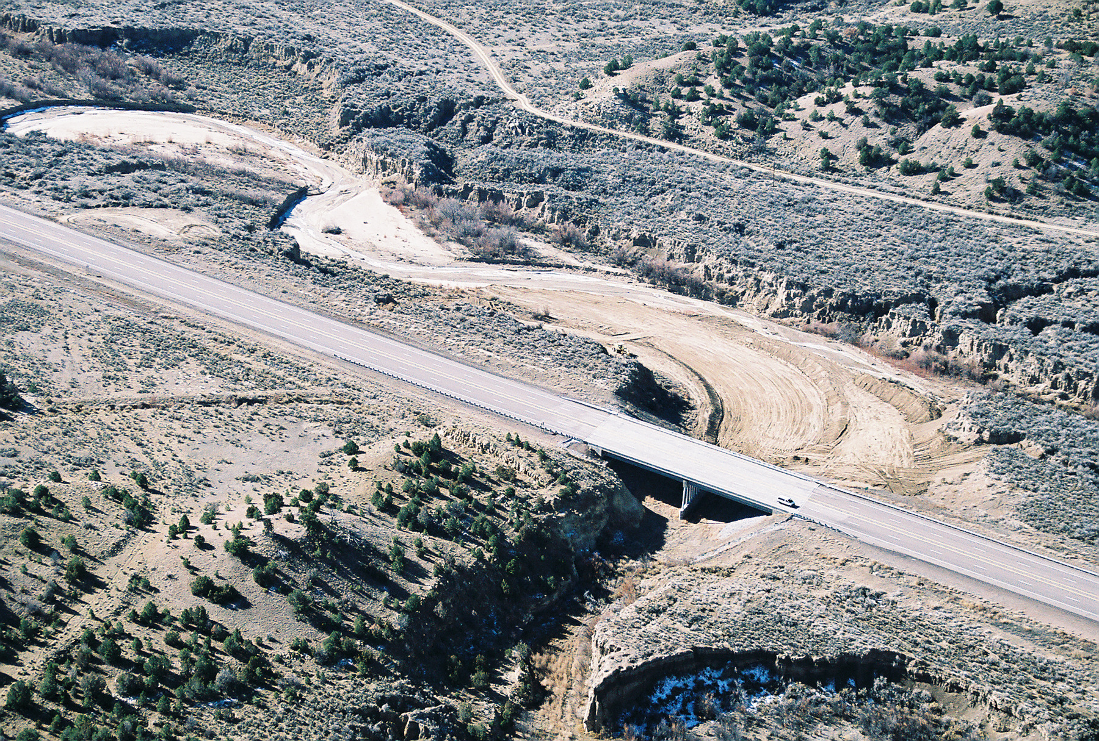

Project Map and Description:

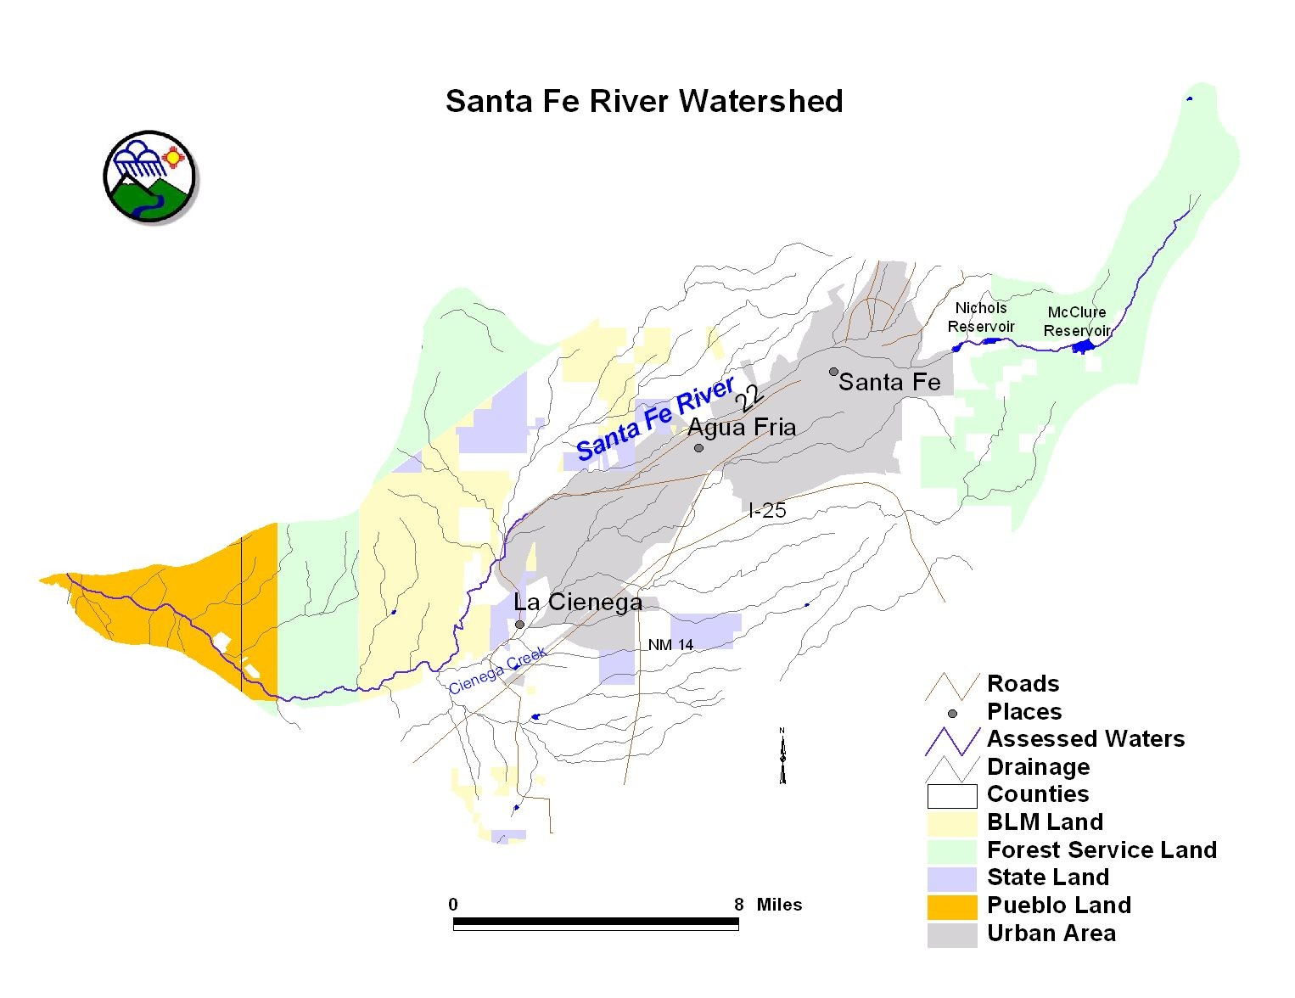
Santa Fe River Restoration Project (2000 $144,650 federal grant, $155,750 match, $300,400 total)

- Forest Guardians received a grant to establish a healthy riparian community on a section of City of Santa Fe property below the Wastewater Treatment Plant.

- BMP’s implemented include fencing of riparian habitat to keep out cattle but allow pedestrian and wildlife access, planting shrubs and woody vegetative species to increase shade and bank stability.

- levees have been changed to allow the river access to the floodplain without damaging the roads.

Project History:

The Santa Fe River has been on the state’s list of impaired waters. Like many river systems in the Southwest, the river has been modified by numerous activities, which have each individually and synergistically severely modified the river’s function. According to the state’s most up-to-date 303d list stream-bottom deposits, dissolved oxygen, PH and temperature impact the stream.

Past Successes:

- Since 2000 Forest Guardians has successfully removed livestock and prevented trespass cattle,
- Planted more than 5,000 cottonwoods and more than 15,000 willows on this stretch of the Santa Fe River. Planting programs have been carried out by more than a dozen different Santa Fe area schools.
- Hundreds of New Mexico residents have participated and donated their labor to the goal of restoring this stream. These hands on restoration efforts, combined with favorable print media coverage about our efforts, have educated countless New Mexico residents about the need to protect and restore native riparian/wetland communities.

Current Challenges:

- Though a small number of local community members voiced their opposition to the restoration project in 2001, and eventually forced the project to be halted for a period of time, we believe the rapid recovery of the area and the overwhelming community support created a popular mandate that city leaders acknowledged. In addition, our efforts to open lines of communication with community leaders in La Cieneguilla and La Cienega and with the Santa Fe River Commission and the City Council diffused the tension and helped to create a consensus, even amongst our opponents, that the project should be completed.
- Although the scope of the project changed significantly with the decision to not create wetlands, and the decision to intensify non-native tree removal efforts, we managed to adhere to the budget and were able to complete the significant task of removing nearly 4,000 non-native trees.

Future Plans:

La Cieneguilla Open Spaces / Santa Fe River Restoration (2005 $101,433 grant, $40,573 match, $142,006 total)

- Santa Fe County Open Space program, in partnership with Forest Guardians, is proposing to conduct a restoration of riparian/wetland habitat on the Santa Fe River.

- County is interested in collaborating with Forest Guardians because of a shared desire to implement a plan to restore and manage this critical piece of County Open Space lands.

Project Photos:
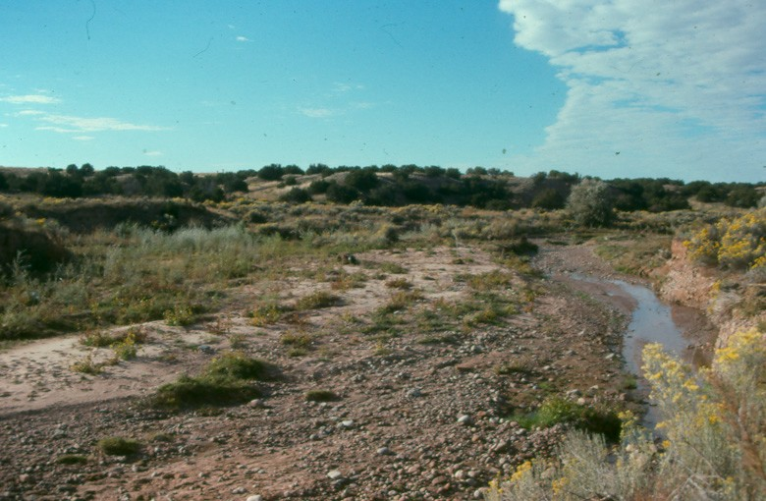

Project 00-E: Santa Fe River below the wastewater treatment plant. This section of City property had been subject to grazing. Before treatment photo 2000.

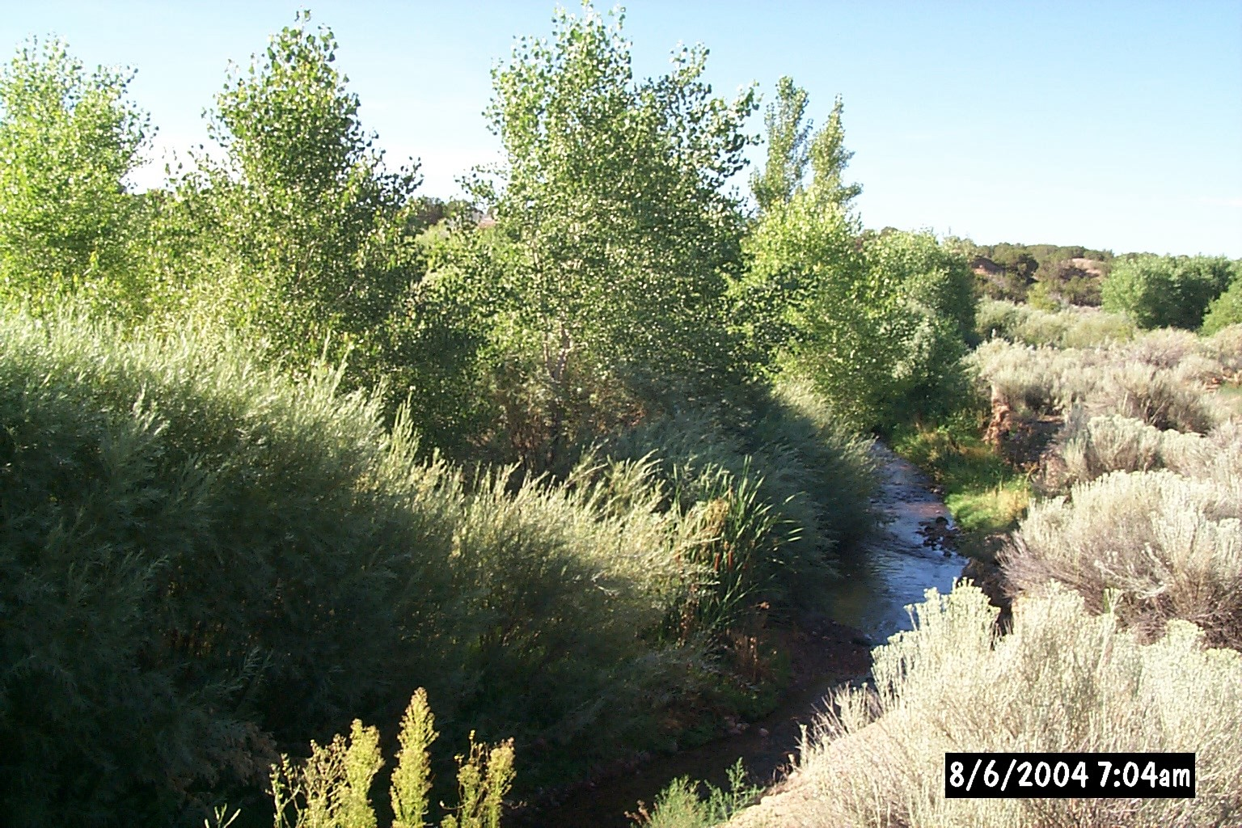
Project 00-E: Santa Fe River below the wastewater treatment plant. This section of City property had been subject to grazing. After treatment photo 2004.

