Request for Proposals for
Watershedwiser.org
Website Upgrades & Additional Features
by River Source, Inc.

Introduction

River Source, Inc. is working with the New Mexico Riparian Council, Cimarron Watershed Alliance and the Forest and Watershed Restoration Institute at Highlands University to improve data-to-information tools (graphing and metrics), functionality to data sharing tools, and content management system (CMS) upgrades through the Watershewiser Project. Watershedwiser.org was created by the Cimarron Watershed Alliance, NM Forest and Watershed Restoration Institute, and River Source as a collaborative tool for sharing ecological data in 2008 on a Drupal CMS. The proposals are being sought by River Source, a company based in Santa Fe, New Mexico.

River Source seeks the services of a website and database development consultant to design, create, test, and deliver an improved version of Watershedwiser.org for use by the general public and professionals in the land and water health fields.

Proposal Specifications

- Improve data entry and graphic display of benthic macroinvertebrate data
-> Create two levels of entry -
1. the basic sort to 6 major groups – Ephemeroptera, Plecoptera, Tricoptera, Chironomidae, Other Diptera, and 2.
the more detailed sort to more detailed major groups as shown in the current database configuration.
-> Fix EPT index by dividing it all by the total INCLUDING Other
-> Add Lepidoptera to more detailed major groups
- Improve chart graphing display for line graphs showing water chemistry monitoring results.
- Add metadata fields at the project level so users can describe how, when, where, why they are collecting and analyzing ecological data
- A graphical-user interface or embedded link to such as to Vertices Imrivers.org-type tools with ability to overlay points and lines using shape files [.shp]).
- A simple and time efficient way to make repeat photography tied to locations and tags.
- A vegetation data entry form to accept species/functional group / percent cover per sample area. The entries will need a link to the USDA Plants Database codes (a filter to align with the 4-5 character code the USDA gives to each species).
- Increase the speed of the front page loading.
- Upgrade to the latest version of Drupal CMS
- Develop a system that will contain basic data output graphing and analysis features such as graphing and simple statistical processing to present environmental metrics. Overlaying multiple parameters (Non-native species diversity vs. native species diversity summarized from multiple transect lines or functional group metrics such as dominance of species.). Graphing air temperature compared to water temperature over time and fluctuations in groundwater well measurements (see graph on page 2).

- The system should generate a number of standard reports, such as calculated metrics of tabular data (ratios of native plant species diversity versus exotic species diversity, species of benthic macroinvertebrates that are intolerant of pollution versus more tolerant aquatic organisms, for example).

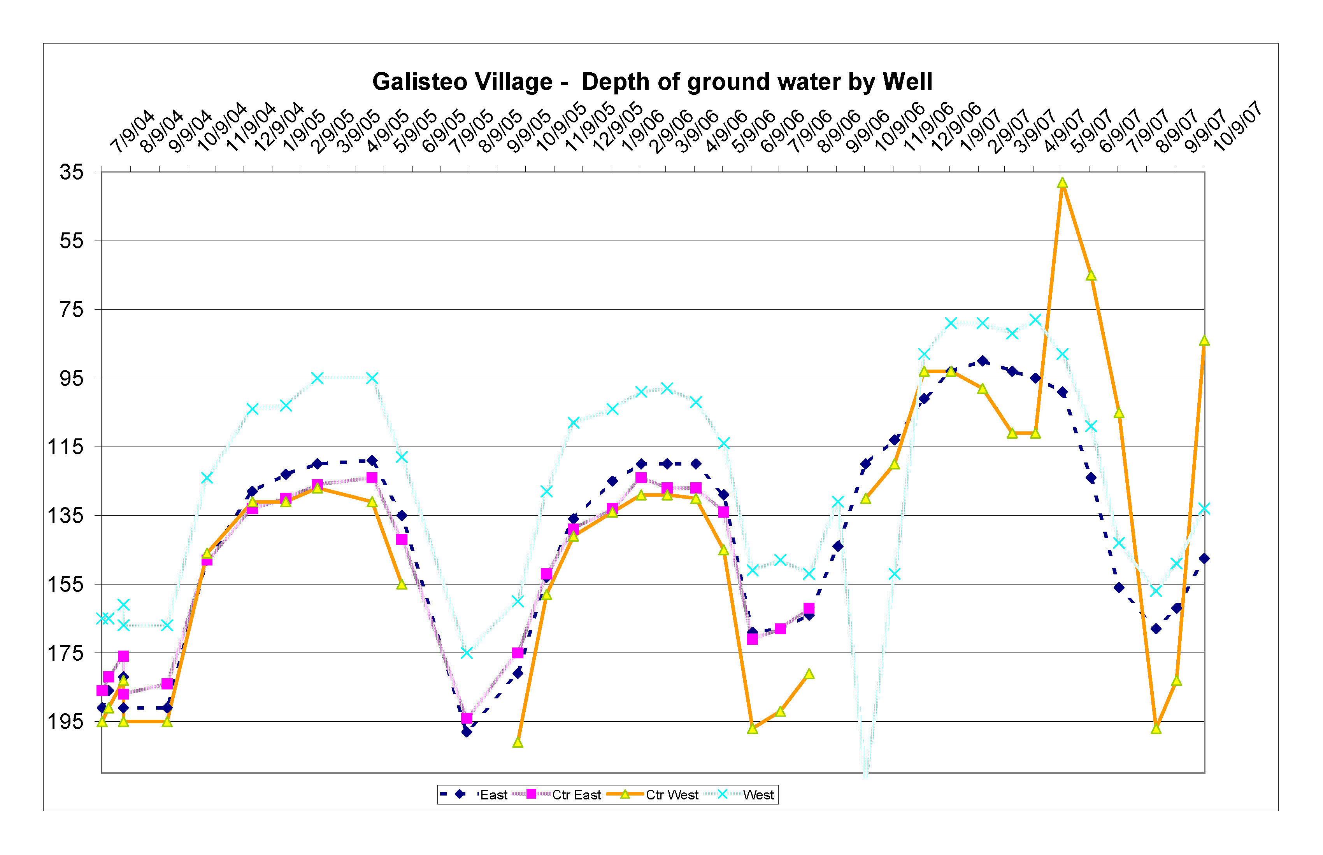
- The system should be created by using off-the-shelf applications or open source software, where feasible. The potential replication of the system with other groups desiring on-line data management tools is desirable, particularly in ways that reduce design and licensing costs. The current operating system on a Drupal CMS provides the current foundation and future CMS packages may be considered if such a change can stay within current budget constraints.
- The system should be engaging to young adults, and allow presentation of photos, videos, and other graphic information through media.

Proposals
Two copies of the proposal should be sent to River Source at 2300 West Alameda, A6, Santa Fe, New Mexico, 87507 no later than August 3 at 5pm. .

Proposal format - Please conform to the following format in preparing proposals.
- Introduction of bidding company, including description of its web and database design and consulting experience for inter-NGO and government (public-private) collaborative data sharing projects.
- Statement of qualifications, experience and billing rates for all individuals who will be assigned to work on the project directly. Please know that River Source will be accepting inquiries about this request until July 29, 2010.
- Description of bidder’s approach to the project, including estimated time frame for completing milestones, including but not limited to an initiation meeting with River Source, ensuing work schedule, periodic progress reviews, delivery of pilot database, upgrades, training and project completion.
- Estimate of personnel costs and direct costs provided separately and the number of hours to be expended for each phase of the project.

- A list of any relevant licenses, certificates, or other professional and training credentials, including those pertaining to Natural Resource database design and web-based GIS application experience.
- A list of at least three relevant references including contact information.
- A statement describing any expected intellectual property rights that the bidder would assert as a result of the project as well as policies for transferring, selling or sharing these rights.
- Any other relevant information the bidder believes would be helpful in assessing the bidder's capabilities, reliability and product quality including projected on-going maintenance costs.

Please submit proposals by August 3, 2010 by 5pm to
Rich Schrader, River Source Inc.
rich@riversource.net
505-660-7928

Questions may be addressed to Rich Schrader with a preference for questions in writing at the email provided above.

