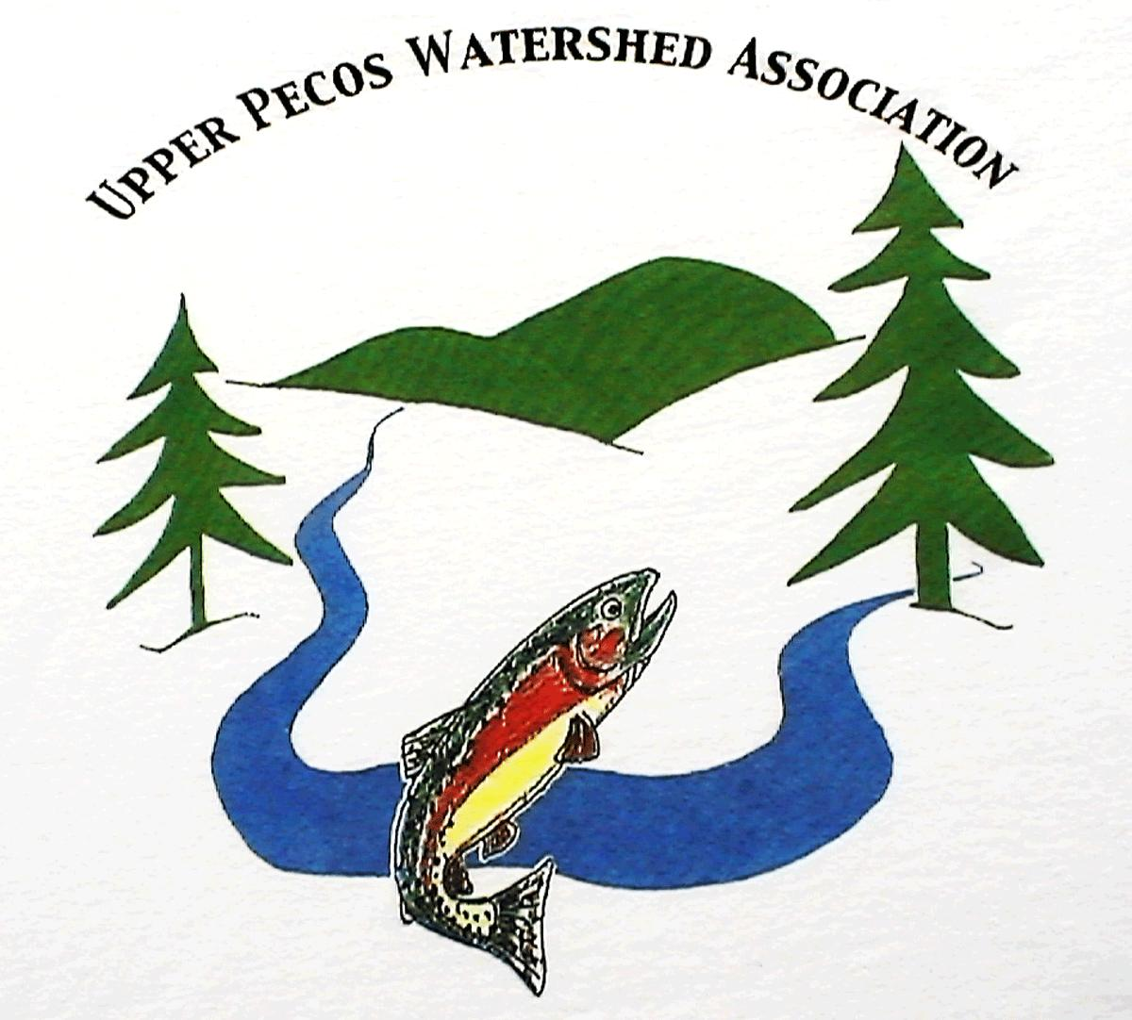

PO Box 489
Pecos, NM 87552
(505) 757-3600
upwa@cybermesa.com
Fact Sheet

The Upper Pecos Watershed Association (UPWA) was formed in June 2006 utilizing grant funds available under section 319 of the Clean Water Act, awarded by the New Mexico Department of the Environment, Surface Water Quality Bureau. UPWA covers the watersheds of the Pecos River and all of its tributaries, including Cow Creek, north of I-25, to their headwaters. UPWA is a New Mexico 501(c)(3) charitable organization, with IRS tax-exempt status.

UPWA’s primary goals are to:
- Protect and improve the health of the watershed
- Address significant ecological, and environmental issues in the watershed
- Preserve traditional and cultural uses and benefit the local economy.
UPWA holds public meetings to:
- Inform watershed stakeholders of UPWA’s work and progress
- Present information of general interest relating to the watershed
- Give stakeholders the opportunity to provide input on issues of concern.

UPWA is the watershed’s coordinator for all the public and private entities with interests in the watershed; including the National Park Service, Forest Service, NM Department of the Environment, NM Department of Game and Fish, NM Departments of Parks, San Miguel County, Village of Pecos, advocacy groups as well as the numerous private landowners in the watershed.

UPWA receives funding from a mix of government and private grants, plus essential private donations, both in cash and in kind. Grants typically do not cover all of UPWA’s necessary administrative costs and we must rely on private donations to help cover maintaining our office in Pecos and part-time staff. Most UPWA grant funds must be matched with direct or in-kind donations. UPWA conducts events such as river cleanups, field days, and other volunteer projects and utilizes all volunteer hours for such events as match. Grants are typically “reimbursement only” funding which creates a need for “seed capitol” thus making fundraising even more critical for the organization.

UPWA must raise $50,000 annually in addition to grant funding!

