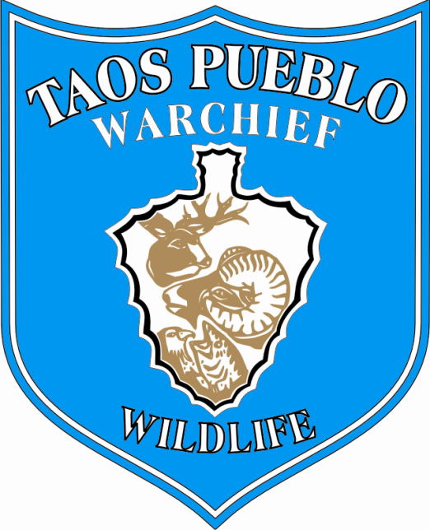
Position announcement:
WILDLIFE ECOLOGY SPECIALIST
Announcement date: November 10, 2010
Position overview, Wildlife Ecology Specialist: Full time; this is an ongoing career-conditional appointment based upon performance and funding review cycles.
Contact person: Sylvia Rains Dennis, Ecology Programs Director
Work location: Ecology Programs Division, Wildlife & Habitat Conservation Department;
Taos Pueblo WarChief’s Office
Mailing address: P.O. Box 2596, Taos, NM 87571
Phone: 575-758-3883; email: tpgfdept@taospueblo.com
Preferred Start Date: November 29, 2010 or within two weeks of application.
Qualifications:
Expertise in field and practical applications of Wildlife Ecology, to include a combination of coursework, professional experience and knowledge of wildlife native to the Southern Rocky Mountains and Upper Rio Grande Region. Additional qualifications include: experience in raptor and songbird identification and habitat analysis, deer/elk population management, and bighorn sheep conservation. Under the supervision of the Ecology Programs Director, this position also supports evaluations, monitoring and program development for rare, threatened and sensitive species and their habitats. For example, Taos Pueblo currently participates in several ongoing, collaborative wildlife species reintroduction projects and special management programs. Field work in widely ranging conditions is required. Experience with field mapping, GPS and GIS applications highly desirable. Degree in Wildlife Ecology or a related science background with extensive field applications and grant experience preferred.
Work responsibilities:
As a key part of the Ecology Programs Division, the Wildlife and Habitat Conservation Department directs all habitat- and species-based inventory, site assessment, and restoration efforts to assure the ecological sustainability of all wildlife within their natural environment. The Wildlife Ecology Specialist will contribute to ongoing and developing wildlife programs, conduct health and population assessments for key wildlife species, as well as participate in biodiversity planning and management within the Ecology Programs Division.
As a primary focus of the Ecology Programs Division, the Wildlife and Habitat Conservation Department supports wildlife and habitat-based analysis, condition assessment, restoration programs and multi-jurisdictional collaboration regarding issues affecting Taos Pueblo lands. The Wildlife Ecology Specialist contributes to cultural ecology program development, including the ongoing management of traditional subsistence and population-based hunts.
In addition, this position prioritizes and conducts a full range of habitat-based wildlife assessments as well as species-level programming, with duties ranging from biodiversity and ecological condition assessment to comprehensive species evaluation and management. The Wildlife Ecology Specialist also supports Ecological Services collaborations and the development of community outreach initiatives, including presentations, specialized training and education.
Career outlook:
The Wildlife Ecology Specialist will participate in professional meetings and conferences, make presentations, and collaborate with the Ecology Programs Director to extend career development and cross-training opportunities for the Wildlife and Habitat Conservation Department and related Ecology Programs. The position will be eligible to enroll in regional and national certification courses, such as the Southwest Willow Flycatcher, Riparian Assessment and developing and/or established training protocols. Current projects include collaborations with the Wild Sheep Foundation, otter recovery, fisheries evaluation, and intertribal programs emphasizing specific wildlife topics.
All training and career development pathways will incorporate cross-training opportunities for Taos Pueblo staff, Wildlife and Stream Ecology Technicians, and Survey Team members. Working closely with the Ecology Programs Director, the Wildlife Ecology Specialist will support the development of mentoring, community outreach and related training programs, as well as offer grant support as requested. This position will coordinate with the Ecology Programs Director regarding participation and attendance at local, regional and national conferences and events, including booth and presentations for The Wild Sheep Foundation, national ecology and wildlife science organizations, and a range of interdisciplinary collaborations.
Wildlife Ecology and Habitat Conservation are key aspects of the cultural-ecological sustainability focus under the Taos Pueblo WarChief’s Office of Natural Resources Protection. Work responsibilities will encompass the full range of wildlife ecology concerns, including traditional and contemporary game management considerations, proposed and designated Wilderness, Conservation, and Outstanding Natural Resource Waters, including a portion of the first designated National Wild and Scenic River (Upper Rio Grande). Within the Ecology Programs Division, this position supports team efforts in Taos Pueblo’s developing Stream Ecology program and the expansion of several Restoration Ecology collaborations, thus serving a critical role in biodiversity corridor and watershed level analysis.
To apply: Please submit a current résumé with full contact information and a cover letter describing your interest in this position to Sylvia Rains Dennis at the Ecology Programs Division address or email listed above. We will contact qualified applicants to arrange an interview.
Please submit applications by 11/29/2010. Anticipated start date within two weeks.

