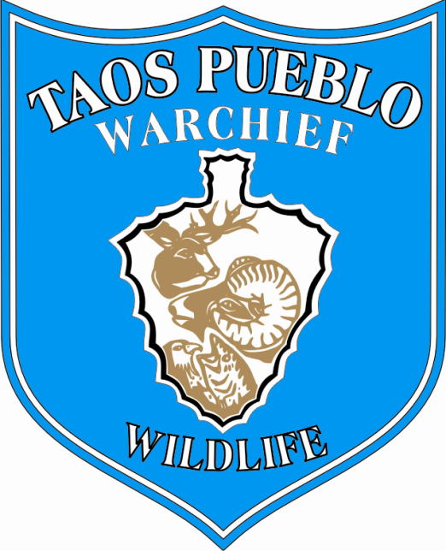
Position announcement:
STREAM ECOLOGY/AQUATIC BIOLOGY TECHNICIAN
Announcement date: November 9, 2010
Position overview, Stream Ecology/Aquatic Biology Technician:
Full time, seasonal; full-year career appointment anticipated within one to two years of hire date based upon performance and funding. On-the-job training and concurrent enrollment in professional/educational courses possible, depending on experience and qualifications.
Contact person: Sylvia Rains Dennis, Ecology Programs Director
Work location: Ecology Programs Division, Wildlife & Habitat Conservation Department;
Taos Pueblo WarChief’s Office
Mailing address: P.O. Box 2596, Taos, NM 87571
Phone: 575-758-3883; email: tpgfdept@taospueblo.com
Anticipated Seasonal Employment period:
2010: Hire date to Dec. 31, 2010
2011: May 16, 2011 to September 30, 2011 (extension possible depending on funding)
Qualifications:
Stream survey methods and aquatic biology training, to include a combination of coursework, professional experience and knowledge of freshwater ecosystems within the Southern Rocky Mountains and Upper Rio Grande Region. Field work in widely ranging conditions is required. Experience with field mapping, GPS and GIS applications highly desirable. Degree or degree-candidates in Fisheries Biology, Stream Ecology and Aquatic Biology are encouraged to apply.
Work responsibilities:
Stream survey to include aquatic (in-channel and lake) habitat; fish and aquatic organisms; stream ecology; and, full participation with Ecology Programs Division wetland and riparian assessment teams. Baseline analysis, condition assessment, restoration programs and collaboration on stream and habitat quality. Identify, collect and analyze fish, aquatic plants, insects and other species.
Contribute to biodiversity and ecological condition evaluations, two key elements of the Wildlife and Habitat Conservation Department. This position also supports Ecological Services collaboration and the development of community outreach initiatives, training and education.
Career outlook:
Grant assistance and successful project implementation to initiate aquatic biology, fisheries and stream ecology as core areas within the Ecology Programs Division. Within two years, this position may convert to full-time, year-round status as more funding becomes available. The Stream Ecology/Aquatic Biology Technician position is expected to include several career development and cross-training opportunities, as well as offer assistance during survey team training sessions and educational workshops.
This position is a key element of the cultural-ecological sustainability focus under the Taos Pueblo WarChief’s Office of Natural Resources Protection. Work responsibilities will encompass the full range of freshwater ecology concerns, including traditional and contemporary use considerations, proposed and designated Outstanding Natural Resource Waters, and a portion of the first designated National Wild and Scenic River (Upper Rio Grande). The Stream Ecology/Aquatic Biology Technician will contribute to biodiversity corridor and watershed level collaboration.
To apply: Please submit a current résumé with full contact information and a cover letter describing your interest in this position to Sylvia Rains Dennis at the Ecology Programs Division address or email listed above. We will contact qualified applicants to arrange an interview.
Please submit applications by 11/29/10. Anticipated start date within two weeks.

